Jordan Funeral Home, Inc.
PO Box 46
Monticello, Georgia 31064
706-468-6303
Fax: 706-468-2205
Email: jordanfh@bellsouth.net

Clifford Milton Aiken, age 99 of Shady Dale, died Friday, December 29, 2023, at The Retreat Nursing Home.
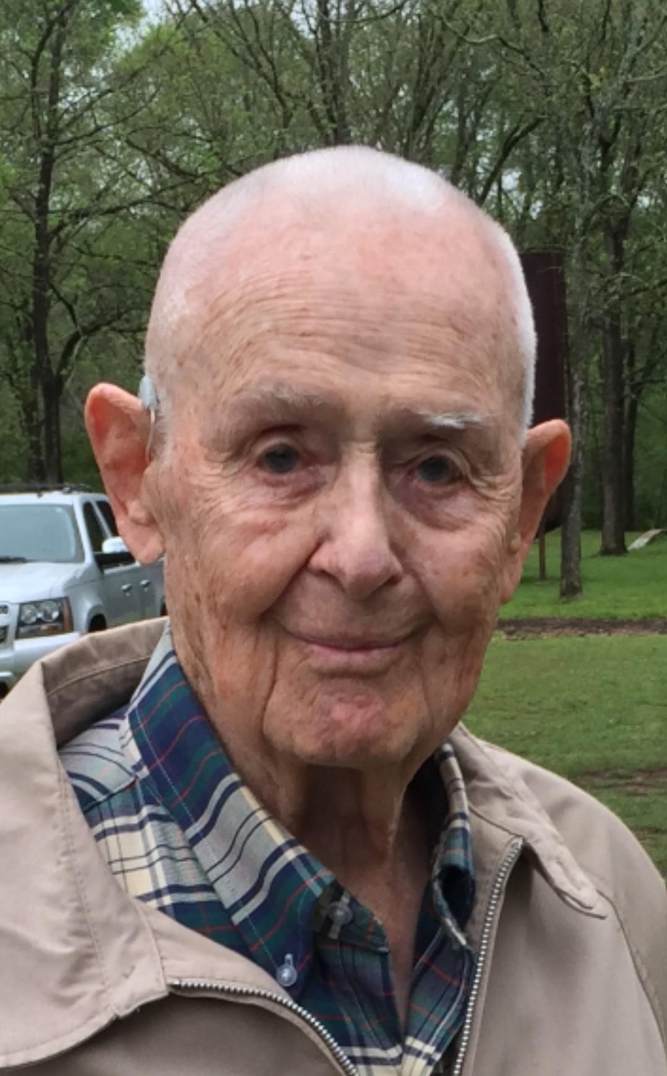

Milton was born March 22, 1924, in Aikenton, Georgia near Shady Dale to the late Corinne Baynes Aiken and Clifford W. Aiken. The youngest of six children, he had five sisters, Virginia, Annie Ruth, Dorothy, Bessie Dean, and Rene.

Milton served in the U. S. Navy during World War II. After the war, he was employed as a civil service employee at Robbins Air Force Base in Warner Robins, Georgia until his retirement. He married Joan Brown from Dublin, Georgia, who was also employed at the base, and they made their home in Macon, Georgia. While still working at Robins, he started a dairy farm in Shady Dale where they ultimately made their home living a meaningful life of purpose and gratitude. Milton loved spending time with his family, working on his beloved farm, and serving his community.

As a Jasper County Commissioner in the mid-1970s, he made positive changes in the community he loved. He retired from the base in 1970 with twenty-eight years of service and continued farming full-time. Milton and Joan were part of the group of founding parents of Piedmont Academy. He joined the Masonic Lodge on December 27, 1946, and became a Master Mason on February 7, 1947. He became a member of Al Sihah Shrine June 16, 1947, and was also a member of the Scottish Rite. He was secretary of Walton Lodge 200 from 1982 to 1996 and received his seventy-fifth year pin in 2022. He had served as a Mason for almost seventy-seven years at the time of his death.

Milton was preceded in death by his wife of fifty-seven years, Joan, his father, mother, and all siblings.

He is survived by his son, Cliff (Sandra) Aiken of Loganville, daughter Nora (Mark) Berendsen of Chapel Hill, North Carolina: Grandchildren Christopher Matthew (Dawn) Aiken of Savannah, Corey Bryant (Samantha) Aiken of Loganville, Robyn Carlotta Aiken of Loganville, and William Grayson Powell, Jr., Madison, Wisconsin, Charles Aiken Powell, Cary, North Carolina, Matthew Baynes Berendsen of Raleigh, North Carolina and several nieces and nephews.

The family will receive friends from 10:00 am to 11:00 am on Tuesday, January 2, 2024, at Jordan Funeral Home in Monticello. Graveside funeral services with follow at 11:30 am at Providence Baptist Church Cemetery in Shady Dale.

Serving as pallbearers will be Chris Aiken, Corey Aiken, Grayson Powell, Charlie Powell, Matthew Berendsen, and Gene Dopson.

Jordan Funeral Home is in charge of arrangements.

