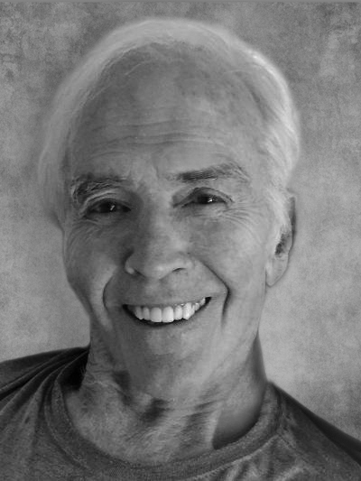
Herschel Allen, Jr. passed away peacefully on April 11, 2020. He was born in Monticello GA, November 30, 1932, to Herschel and Josie Allen and was the devoted husband of Betsy Pritchett Allen of Atlanta. He was a loving, gentle truth-teller with an infectious smile.
Herschel enjoyed playing every sport available at Monticello High School. He attended Davidson College, where he also lettered in several sports. He was a class officer, a member of Phi Delta Theta Fraternity and Omicron Delta Kappa, a Leadership Honor Society. He loved all things Davidson. During college he worked at Glacier National Park where a lifelong love for National Parks began.
Furthering his education, he attended Columbia Seminary where he received a Th.M. in Pastoral Counseling and was ordained as a Presbyterian Minister. He obtained additional training at the Menninger Foundation in Topeka, KS, and The American Foundation of Religion and Psychiatry in New York. He was a Charter Member of the American Association of Pastoral Counselors.
As a lifelong pastoral counselor, Herschel loved being able to work with and help people at times in their lives when his skills made a difference for them. His greatest gift was loving and caring about all people, and his greatest talent through his counseling career was helping his clients learn to love and care for themselves. Among others, he worked at The Bradley Center and the Medical Center in Columbus, GA, and the Georgia Baptist Health Care System and the Peachtree Counseling Center in Atlanta.
Herschel is survived by his wife Betsy; his children Scott Allen (Leslie); Suzanne Allen Valdivia (Raphael); Ashley Walters (BJ); Catherine Livingston (Wayne) and his grandchildren Alex, Elliott, Grace, Claire, Caroline, Callie and Hunter. He was predeceased by his son Anderson H. Allen.
A family memorial service will be held in the Monticello Presbyterian Church cemetery at a later date.
In lieu of flowers, contributions may be made to the Monticello Presbyterian Church Cemetery Fund.
Jordan Funeral Home is in charge of local arrangements.

