Jordan Funeral Home, Inc.
PO Box 46
Monticello, Georgia 31064
706-468-6303
Fax: 706-468-2205
Email: jordanfh@bellsouth.net

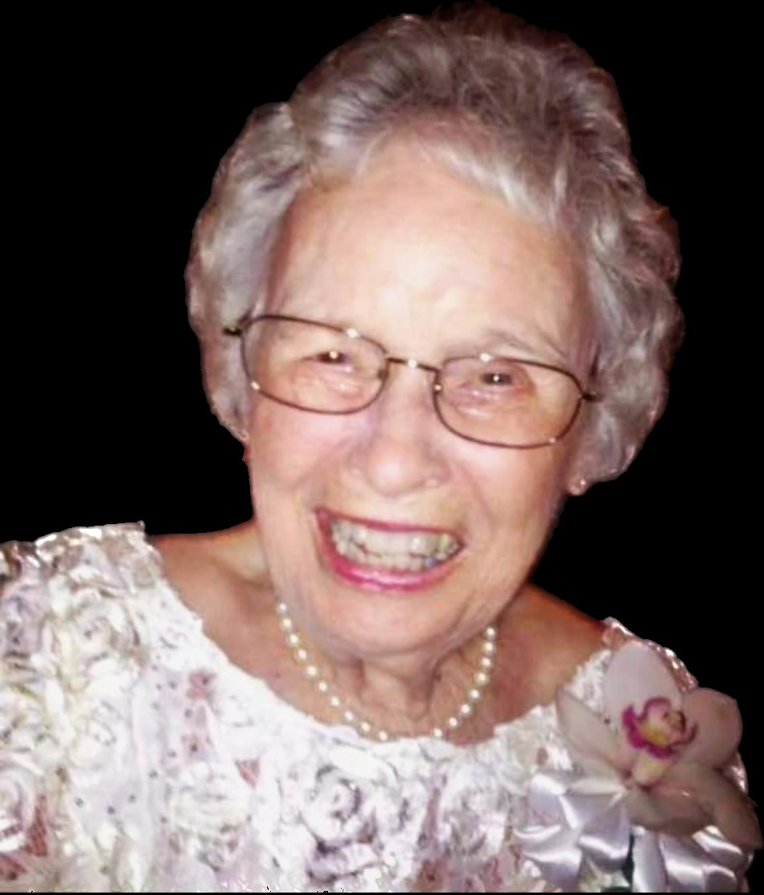
Mabel entered the Stone family on a stormy Thursday night on October 3, 1929. She was the ninth child of eleven children born to Clyde and Harvey Stone. Her arrival into the world was also accompanied by the Great Depression. Life was hard, but she was blessed to be born into a Christian home surrounded by people who loved her.

She graduated from high school and soon married Joseph Franklin McMichael, Jr. They began a family of two daughters and a son. Again, she was surrounded by a family that loved her. Both of the families of which she was a part lived in Monticello which formed a bond of support and love for each other. Although her life had its trials her resilience was her faith. She belonged to the United Methodist Church of Monticello where she did sing in the choir with Mrs. Jeannette Kelly as the choir director. Mabel left the choir when she felt she could no longer contribute to the choir due to throat surgery. She remained an active member of the Methodist Church until she left Monticello after the deaths of “Junior” and later her son, Joe.

She married Reggie Bennett and again was surrounded by people that loved her. She gained another daughter. She moved from Monticello to the Panama Canal Zone. This was the first time she had lived some place different than Monticello. Returning to Georgia she and Reggie made a home that provided a place for each of her children, grandchildren, great grandchildren, and great-great grandchildren to gather to enjoy each other and her good cooking including her trademark pimento cheese sandwiches.

Her working career began early. In her early teens she began to earn some money by riding a bicycle delivering newspapers. Later she worked at the Sewing Room. She ended her work career at Georgia Pacific. All of her employments were in her home town of Monticello.

Mabel always had a heart of service. She continually wanted to reach out to others. Her notes, cards, visits, phone calls along with taking part in Meals on Wheels were part of her service. Cooking was one way that she expressed love for others. At McDonough Christian Church she was part of Wednesday Night Supper Team and actively involved in Christian Workers Sunday School Class and helping to provide meals for the bereaved of the church. Her reaching out to others was all inclusive. She had a sincere drive to help others. Above all she was continually in prayer for whomever she knew needed help.

In addition to her parents, husbands and son, she was preceded in death by eight siblings.

Mabel died peacefully at home on August 31, 2023, surrounded by loving caregivers, Vicky and Rose and her grandson, Mike. She was 93 years old.

She is survived by her daughters, Dianne (Wayne) Dooley of Jackson, Clydie (Danny) Jones of Rockmart and Andrea (Bill) Dodd of McDonough; grandchildren, Anita Walker, Michael Dooley, Mary Frances (D. J.) McConnell and Suzanne (Thomas) Mathew; nine great-grandchildren; six great-great-grandchildren; and sisters, Bertha Davis of Westminster, South Carolina and Kate Brown of Conyers.

Funeral services will be held at 11:00 A.M., Tuesday, September 5, 2023, at the Monticello First United Methodist Church. Interment will be held in West View Cemetery. Rev. Paul Leslie and Rev. Scott Gregory will officiate.

The family will receive friends from 10:00 A.M. until 11:00 A.M., Tuesday, September 5, 2023, at the Monticello First United Methodist Church.

Serving as pallbearers will be Rhett Smith, Stuart Holt, Scott Sauls, Brian Kelly, Tom Miller and Tim Thaxton.

The family suggests in lieu of flowers donations be made to the Southern Grace Hospice Palliative Care 80 Candler Road Conyers, GA 30253.

Jordan Funeral Home is in charge of arrangements.

