**Jordan Funeral Home, Inc.**

**PO Box 46**

**Monticello, Georgia 31064**

**706-468-6303**

**Fax: 706-468-2205**

**Email:** [**jordanfh@bellsouth.net**](mailto:jordanfh@bellsouth.net)

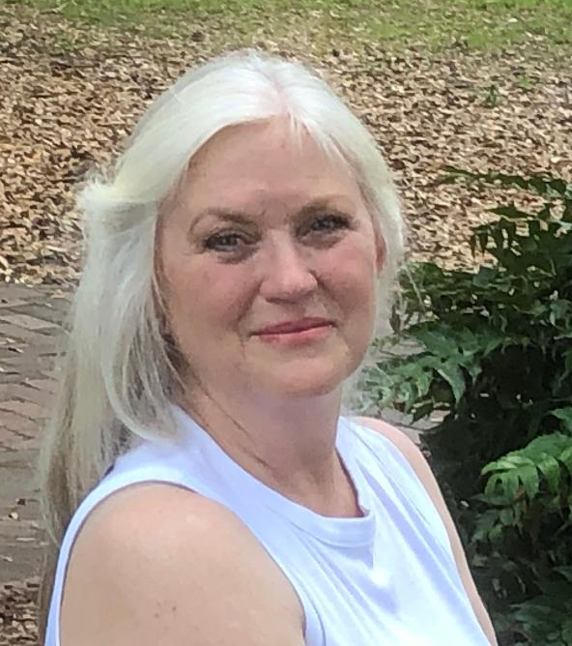

 Andrea "Cissy" Adamson Benton, age 65, of Newborn, went home to be with the Lord on Thursday, June 19, 2025. She was a devoted wife, mother, grandmother, and friend who shared her love and kindness with everyone she met.

Born on February 16, 1960, Cissy was the beloved daughter of the late Chuck Adamson and LaTrelle Wallace. A lifelong resident of Jasper County, she attended public schools in Jasper and Newton counties, as well as Piedmont Academy. She earned a degree in Agricultural Business from Abraham Baldwin Agricultural College.

A true servant's heart, Cissy had a rich and varied career serving her community. She served for thirteen years as a postal carrier and over thirty years as an election poll worker, including many years as Captain and as Executive Director of the Monticello-Jasper County Chamber of Commerce. Cissy became the Director of historic Thomas Persons Hall, where she had attended elementary school, bringing her love of people, the arts, community, and history together.

Cissy dedicated many years to volunteering with local organizations and community events, always stepping in where help was needed with a joyful spirit. She was actively involved in Kiwanis and served as Lieutenant Governor for her district. With all of her sons participating in the school marching band, she served for over ten years with the Band Boosters, including many as President, where she worked tirelessly to support fundraising efforts.

Cissy found great joy and peace on her family farm, Beulah Land, where she lovingly cared for her horses, from miniatures to draft, and any animal that wandered up to her front porch. Cissy also enjoyed antiques, always finding joy in uncovering forgotten treasures that told stories of the past.

Faith was the foundation of her life. She loved the Lord with all her heart and served Him joyfully. A devoted member of many years at First Independent Methodist Church in Eatonton, she led praise and worship, blessing her church family with her beautiful voice, spirit-filled presence, and anointed piano playing.

Cissy's greatest joy in life was her family. She was married to the love of her life, Mike Benton, for thirty-six wonderful years. Together, they built a life filled with love, laughter, and unwavering devotion to one another. Cissy was the proud mother of three wonderful sons: Michael Samuel Benton (Ansley) of Madison, John Matthew Benton (ScottiAnn) of Monticello, and Benjamin Daniel Benton (Jolee Battles) of Savannah. She adored being "Grammy" to her beloved grandson, Bearett "Bear" Adamson Benton.

She is also survived by her loving brothers, Chuck Adamson (Laura) of Newborn and Donnie Adamson (Lori) of Mansfield; her second-mom, Emmie Adamson of Conyers, as well as many cousins, nieces, nephews, and friends who became like family.

The family will receive friends on Tuesday, June 24, 2025, from 6:00 to 8:00 p.m. at Thomas Persons Hall, 319 College Street, Monticello, Georgia 31064. A Celebration of Life will be held at 11:00 a.m. on Wednesday, June 25, 2025, at First Independent Methodist Church, 107 Imperial Church Road NW, Eatonton, Georgia 31024.  Pastor Ron Smith and Rev. Gene Head will officiate.

Serving as pallbearers will be Chuck Adamson, Donnie Adamson, Eric Schremmer, Michael Brock, Coleman Hadden and Bruce Henry.

The family suggests in lieu of flowers donations be made to the Thomas Persons Hall or First Independent Methodist Church in Eatonton.

Jordan Funeral Home is in charge of local arrangements.  Please visit our website at www.jordanfuneralhomemonticello.com.