Laree Malone Benton

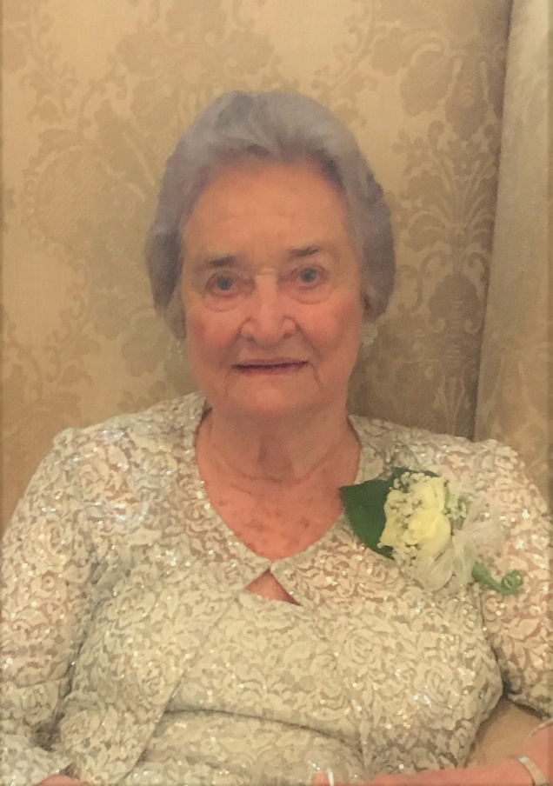
Laree Malone Benton, age 93 passed away Wednesday, December 1, 2021, at Abbey Hospice in Social Circle.

Laree Benton was born on January 26, 1928 to the late Leon Eugene Malone and Irene Roberts Malone in the Hopewell community of Jasper County. A proud lifelong resident of Monticello, Laree graduated from Monticello High School. She attended Emory at Oxford before graduating from the University of Georgia in Athens, Georgia and was a proud member of Kappa Alpha Theta sorority.

Laree married James Frederick “Fred” Benton, Jr. on November 23, 1950. She was a respected Science teacher at Monticello High School, business owner of Katheryn’s Flowers and City Council member in Monticello.

Laree loved to travel near and far. She also enjoyed her home in Highlands, North Carolina for the past twenty-two years.

In addition to her parents, she was preceded in death by her husband, Fred Benton, Jr.; son, James Frederick “Buster” Benton, III; and son-in-law, William Allen “Bill” Felts, Jr. of Thomasville.

She is survived by her daughter, Rebecca “Becky” Benton Felts of Thomasville; son, Eugene Malone “Gene” (Christie) Benton of Monroe; grandchildren, William Allen “Will” (Annais) Felts and Boone Benton Felts of Thomasville, Amelia Benton (Porter) Henritze of Atlanta and Eugene Bartlett (Whitney) Benton of Monroe; great grandchildren, Allie Felts, Freddie Henritze, Amy Rae Benton, Hanson Rollins and Jaxson Rollins.

Funeral services will be held at 2:00 P.M., Wednesday, December 8, 2021, at the Monticello First United Methodist Church. Interment will be held in West View Cemetery. Dr. John Brown and Pastor Kara Wilson will officiate.

Serving as pallbearers will be Doug Huff, Joseph Gasses, Jimmy Ezell, Tommy Jordan, John Mays, Will Felts, Boone Felts, Bart Benton and Porter Henritze.

The family will receive friends from 1:00 until 2:00 P.M., Wednesday, December 8, 2021, at the Monticello First United Methodist Church.

The family suggests in lieu of flowers donations be made to the Monticello First United Methodist Church, 651 College Street, Monticello, Georgia 31064.

Jordan Funeral Home is in charge of arrangements.

