Jordan Funeral Home, Inc.
PO Box 46
Monticello, Georgia 31064
706-468-6303
Fax: 706-468-2205
Email: jordanfh@bellsouth.net

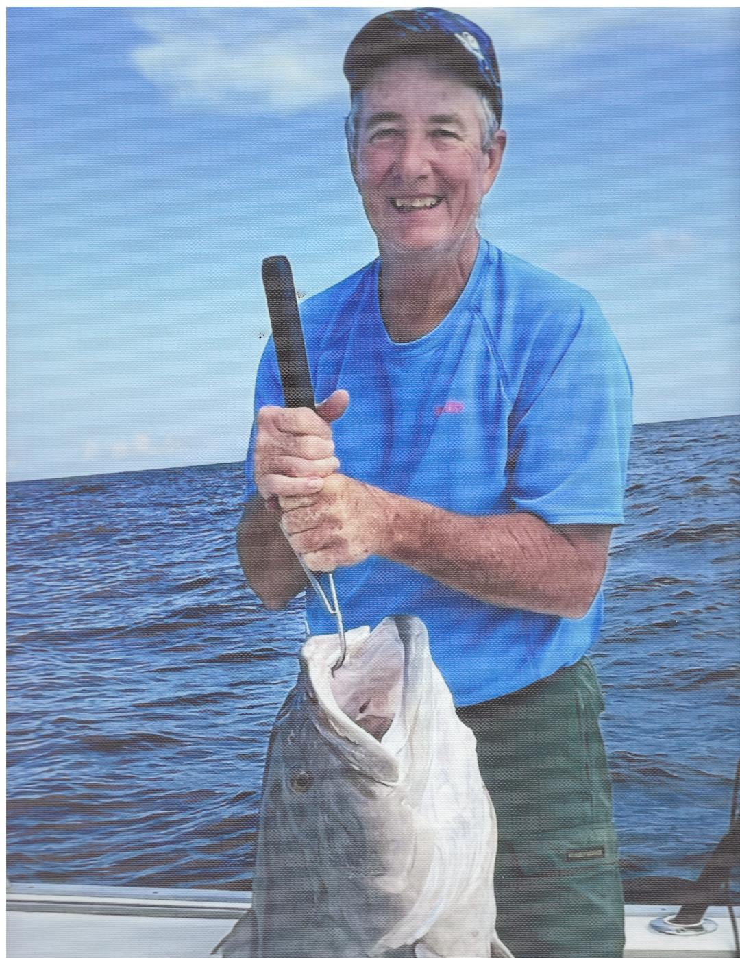
Frank Edward “Ed” Burrell, age 70, passed away Saturday, March 29, 2025, at his residence.
Ed Burrell was born on April 10, 1954 in Monticello, to the late Frank Loyd Burrell and Nancy Lorena Edwards Burrell. He was a lifelong resident of Jasper County.

After graduating from Monticello High School in 1972, he worked for the Pope Brothers Logging Company. He then went to work for Dexter Axle in Monticello for about ten years. Before retirement, he worked as a forestry technician for the U. S. Forestry Service for twenty-three years where he found his true passion-fighting fires. He fought fires nationwide from Oregon to Florida; and was a volunteer fire-fighter for over twenty years with the Jasper County Fire Department.

Ed was a devoted member of the Monticello Baptist Church. He was a true “jack of all trades” and could fix almost anything. He always tried to make it to the Dairy Queen for lunch to see his buddies. He was very kind but he didn’t always let it be known. Always outspoken, he enjoyed talking politics with anyone that would listen. He loved to fish, hunt and work on the farm. He loved to joke and had a great sense of humor that the family will truly miss.

In addition to his parents, he was preceded in death by his brother, Thomas Loyd Burrell.

He is survived by his niece, Mariah (Eric) Wojdacz of Monticello; nephew, Thomas Burrell of Monticello; great-nieces and nephews, Chandler (Rileigh) Burrell, Scarlett Wojdacz, Ben Wojdacz, Sunny Burrell and Isaac Wojdacz; great, great-niece and nephew, Mila Burrell and Tate Burrell; step-daughter, Magen (Maylon) Wages of Panama City, Florida; and step-grandchildren, Taylor Wages and Tyler Wages.

Graveside services will be held at 2:00 P.M., Friday, April 4, 2025, at West View Cemetery. Rev. David Artessa will officiate.

The family suggests in lieu of flowers donations be made to the Monticello Baptist Church, 334 W Greene Street, Monticello, Georgia 31064.

Jordan Funeral Home is in charge of arrangements.

