Jordan Funeral Home, Inc.
PO Box 46
Monticello, Georgia 31064
706-468-6303
Fax: 706-468-2205
Email: jordanfh@bellsouth.net

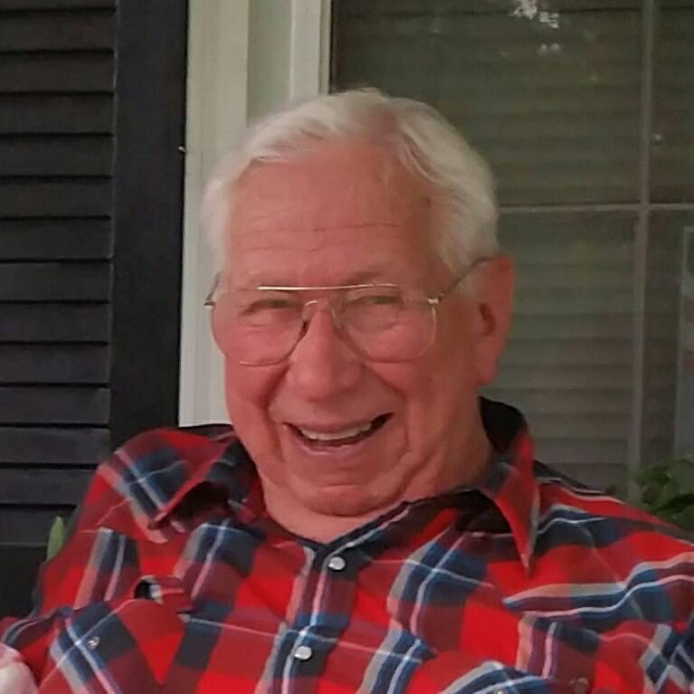

A.J. Junior Champion
8/28/1932-6/1/2022

- J. Junior Champion, age 89, passed away Wednesday, June 1, 2022, at his residence
in Shady Dale.

Junior Champion was born in Ellijay, Georgia, on August 28, 1932, to the late Homer James Champion and Mary Elmina Reece Champion. He lived in Ellijay until moving his family to Shady Dale in 1963.

He married the late Margaret Eloise Jones Champion on December 9, 1949 and they were married for sixty-seven years before her death in 2017. After moving to Shady Dale, he and Margaret owned and operated Champion Lumber Company. He built pallets from 1968 until 1998; then he began cutting and selling rough cut lumber until 2022.

Junior Champion was a former Councilman and Mayor of Shady Dale for a total of over thirty years. He was instrumental in establishing the Shady Dale Volunteer Fire Department and the city water system. He served as the first Fire Chief for a number of years.

He enjoyed spending time with his family and would help anyone in need.

In addition to his parents and wife, he was preceded in death by his brothers, Ermel Champion, Billy Champion and Leeman Champion.

He is survived by his children, Larry (Joan) Champion, Karen (Fletcher) Bryan, Lynn (Paul) Ogletree and Gary (Cindy) Champion of Shady Dale; grandchildren, Steven Champion, Kevin Champion, Larissa Ruark, DeAnne Greenway, Brandi McMichael, John Bryan, Jr., Daphne Hrib, Paula Clark, Crystal Sweeney, Holly Geiman, Kimberly Young, Jessica Chandler and Mac Bedor; thirty-three great grandchildren; five great, great grandchildren; and brother, Freeman Champion of Ellijay.

Funeral services will be held at 2:00 P.M., Friday, June 3, 2022, at Providence Baptist Church in Shady Dale. Interment will be held in Church Cemetery. Rev. Edward Westbrook and Rev. Wayne Ghann will officiate.

Serving as pallbearers will be Steven Champion, Kevin Champion, John Bryan, Jr., Terry Clark, Jason Greenway, Mike Hrib, Mac Bedor, James Greenway, Jacob Greenway, Jarrett Greenway, Jackson Greenway, K. C. Champion, Joseph McMichael and Nolan McMichael.

The family will receive friends from 12:30 P.M. until 2:00 P.M., Friday, June 3, 2022, at Providence Baptist Church in Shady Dale.

The family suggests donations in lieu of flowers to Providence Baptist Church Cemetery Fund, P. O. Box 231, Shady Dale, Georgia 31085.

Jordan Funeral Home is in charge of arrangements.

