Jordan Funeral Home, Inc.
PO Box 46
Monticello, Georgia 31064
706-468-6303
Email: jordanfh@bellsouth.net

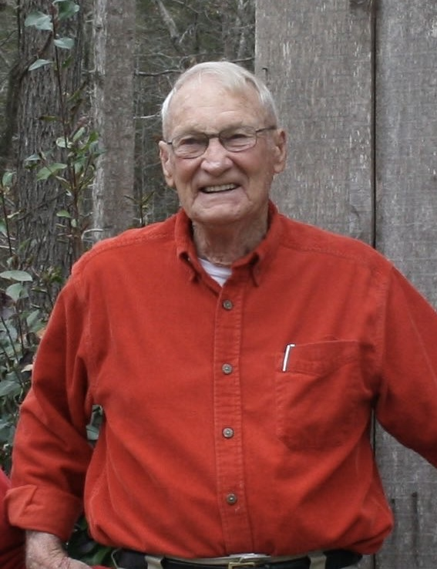
Life is made up of seconds, minutes, hours, days, years and even decades. It is what we choose to do with this time that separates one man from another and defines whom you are. Merrill Lynn Clark, Sr. passed away on Wednesday, September 10, 2025, and went to joyfully meet his wife of seventy-one years and his oldest son in heaven. If only one thing could describe him, it would be that he was a man who chose a life of service.

Born on November 27, 1932 in the Cedar Grove Community of Dekalb County, Merrill was one of eight children. He married the love of his life, Emily Elaine Daniell, on November 22, 1950.

A Marine Corps Veteran of the Korean Conflict, Merrill was a developer and building contractor in Dekalb, Clayton, and Henry Counties for thirty-one years. Growing up on a dairy farm, it was his lifelong dream to own his own farm. In 1978, Merrill and Elaine moved to Shady Dale, Georgia where he operated Shady Dale Angus farm.

Mr. Clark served others, always putting them before himself. He served God by being an avid supporter and active member in his church, Calvary Methodist, serving as church treasurer, as well as hands-on service helping to renovate the church, mowing and caring for the grounds, and doing any maintenance as required.

He served on the local and state levels as well being an active member and, many times the chairman, of several committees and boards, including: the Board of Trustees of Piedmont Academy, the Jasper County Zoning Commission, the Upper Ocmulgee Soil and Water Conservation Service, and the Jasper County Water and Sewer Authority. His love of all thing’s cattle drove him to be a member of the Georgia Cattlemen’s Association for several years.

Merrill’s Masonic Lodge service began in Panthersville Masonic Lodge in 1956 and he continued his service in Jasper County with the Walton Masonic Lodge #200. In 1983-84, he was one of the founders of the Shady Dale Rodeo and had his health allowed, would still be involved today.

Of all that Merrill Clark did over his ninety-two years, his crowning act of service was to his bride and to his family. He was a devoted husband, father, and mentor to five children and their spouses, as well as a wonderful “Paw Paw” to numerous adult grandchildren and young great grandchildren.

Merrill is pre-deceased by his wife, Elaine Daniell Clark and his son Merrill Lynn Clark, Jr (Alisa Dale Clark). He is survived by four children: Daniell Randy Clark (Denise Nunez Clark), Kathie Clark Shemwell (David Baxter Shemwell), Patti Clark Dieterly, and Christy Clark Lischer (Alan Arthur Lischer, III). He is also survived by eleven grandchildren, sixteen great-grandchildren, and three great-great grandchildren. “How blessed is the man whose quiver is full.” Psalm 127:5
As we say goodbye to the man that most men and boys can only aspire to be, we are reminded of what God tells us in Micah 6:8 “What does the LORD require of you but to do justice, to love kindness, and to walk humbly with your God.” We will miss you, Dad.

Funeral services will be held at 11:00 A.M., Tuesday, September 16th at Calvary Methodist Church in Shady Dale. Interment will follow at 3:00 P.M., at Cedar Grove Cemetery, 4211 Connor Drive, Ellenwood, Georgia 30294.

The family will receive friends beginning at 10:00 A.M., at the church during the hour before the service.

Serving as pallbearers will be grandsons, Brad Crosswell, Wes Clark, Brett Shemwell, Stephen Dieterly, Michael Dieterly, Nathan Lischer, Mark Dieterly and Jacob Lischer.

The family suggests in lieu of flowers, donations be made to the Masonic Children’s Home, 1417 Nottingham Drive, Macon, Georgia 31211; or the Walton 200 Masonic Lodge, 21472 Hwy 83 N, Monticello, Georgia 31064 for the endowment for Merrill Clark College Scholarship Fund.

Jordan Funeral Home is in charge of arrangements.

