Jordan Funeral Home, Inc.
PO Box 46
Monticello, Georgia 31064
706-468-6303
Fax: 706-468-2205
Email: jordanfh@bellsouth.net

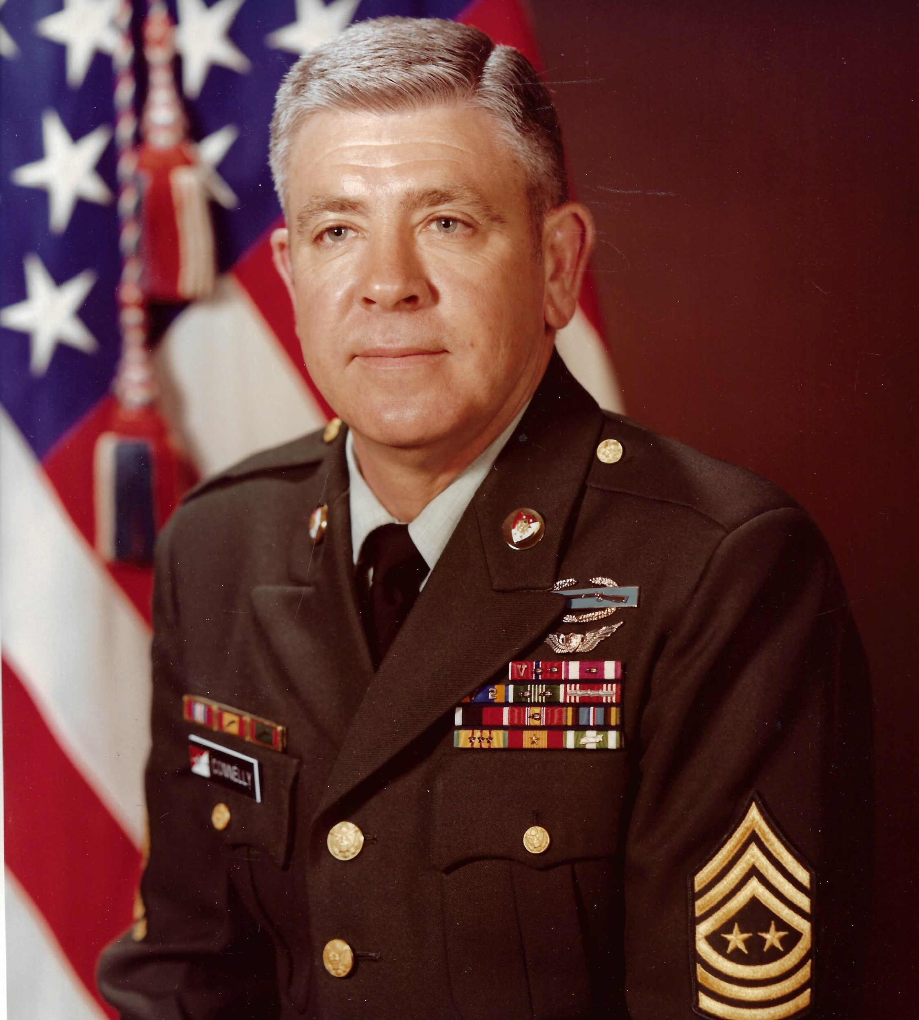
William A. “Billy” Connelly was born in Monticello, Georgia to the
late Paul C. Connelly and Emily Cleora Janes Connelly. In addition to his parents, he was preceded in death by his sisters, Jo Britt and Mary Elizabeth Baker and brother, Paul Herman Connelly.

William A. Connelly served in the United States Army for over
thirty-three years. His career began as a National Guardsman in Americus, Georgia, while attending Georgia Southwestern College. Subsequently he served in various positions worldwide as a tank crewman, tank commander, platoon sergeant and Command Sergeant Major while on active duty status from 1954 until 1983. During the Vietnam War, SMA Connelly served as First Sergeant Troop B, 1st Squadron, 9th Cavalry, 1st Cavalry Division from October 1969 to November 1970. His service included four tours in Europe as well as a tour in the Dominican Republic.

Sworn into office as the sixth Sergeant Major of the Army on July 2, 1979, William A. Connelly served as the principal enlisted advisor to the
Army Chief of Staff regarding matters of the enlisted force. Additionally,
he served on numerous boards and commissions at the behest of the Chief
of Staff. SMA Connelly traveled extensively, meeting and speaking with servicemen and women, in order to voice their concerns to the leadership
of the Department of the Army, Department of Defense and Congress.

His dedicated service in the Army earned numerous awards
including the Distinguished Service Medal; Bronze Star Medal with V
Device with two Oak Leaf Clusters; Meritorious Service with an Oak Leaf Cluster; Air Medal with V Device with two Oak Leaf Clusters; Army Commendation Medal with two Oak Leaf Clusters; numerous campaign and service medals; Combat Infantryman’s Badge; Aircraft Crewman’s Badge; and the Army General Staff Identification Badge. In 2004, SMA Connelly received the Doughboy Award, the highest honor one can receive from the Department of the Infantry.

After retiring from the Army July 1, 1983, he was appointed by President Ronald Reagan as special assistant to the Secretary of the Department Veteran Affairs, where he served for three years. He then served as the Director of Public Affairs and Programs Manager for the Veterans Affairs Hospital, Atlanta, Georgia. SMA Connelly retired from the VA in January 1993.

Staying active within the military community, he served as Co-Chairman of the Chief of Staff of the Army’s Retirees’ Council; Board of Trustees of the Association of the U. S. Army; and on the Board of Directors of the Soldiers and Airman’s Home in Washington, D. C. Subsequently, he was inducted into the Georgia National Guard Hall of Fame in July 2010.

His community service includes serving eight years as Commander of the local American Legion Post 110; Chairman and member of the Economic Development Authority; Director of the Bank of Monticello; and Chairman of the Administrative Council and Trustee of the Monticello First United Methodist Church in his hometown.

He is survived by his loving wife of fifty-two years, Bennie Newton Connelly, formerly of Shady Dale, Georgia; daughter, Carol Emily Connelly of Athens; grandson, Dan (Faith) Clausen of Lawrenceville; great-grandson, Tyler Clausen; and sister, Connie Horne of South Carolina.

Funeral services will be held at 2:00 P.M., Tuesday, November 24, 2019, at the Monticello First United Methodist Church. Interment will be held in West View Cemetery. Dr. John Brown and Pastor Kara Wilson will officiate.

Serving as pallbearers will be Steve Jordan, Don Kelly, Danny Roberts, L. O. Benton, IV, Hunter Pope and Jeff Connelly.

The family will receive friends from 5:00 until 7:00 P.M., Monday, November 25, 2019, at Jordan Funeral Home.

Jordan Funeral Home is in charge of arrangements.

