Jordan Funeral Home, Inc.
PO Box 46
Monticello, Georgia 31064
706-468-6303
Fax: 706-468-2205
Email: jordanfh@bellsouth.net

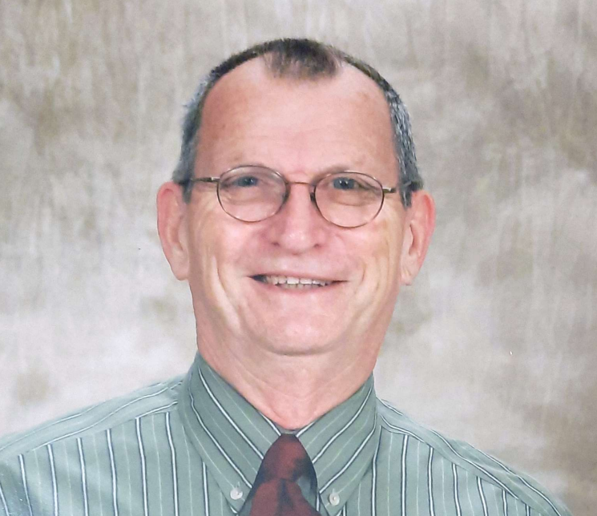

George Lamar Crawley

1/20/1937 – 5/24/2022

Born on the 2nd inauguration day of FDR in 1937, George Lamar Crawley, age 85, passed away on Election Day, May 24, 2022. Lamar was a native of Griffin, Georgia, born on January 20, 1937 to Lee & Annie Lester Crawley. He passed away in his home surrounded by his wife and “his girls” after a long battle with Alzheimer’s disease.

Lamar graduated from Griffin High School in 1955 and from the University of Georgia in 1959 with a Bachelor’s Degree in English. He went on to earn five more degrees from UGA as well; a Master’s Degree was in English, a second Master’s Degree in cooperative education, a third in vocation education and a fourth Master’s Degree in Administration. He later added a six-year (Specialist) Degree in vocational education. His first job was teaching High School English at Brown High School in Atlanta in 1959. During his ten years at Brown, he was selected as STAR teacher four times, 1963, 1966, 1967, and 1969. He also coached the girls’ basketball team, boys’ baseball team, and football during his tenure there. From Brown, he moved into administration in Douglas County. After Douglas County, he moved to Scott Preparatory school in Opelika Alabama as the Headmaster. Piedmont Academy brought him to Monticello as Headmaster in 1974 where he remained until 1977. Following his time at Piedmont, he left education for about six months to sell fruit with a friend from Valdosta. He joined the faculty of Heritage High School in Conyers, Georgia, in January of 1978 where he worked in several roles until his retirement in 2006. In addition to his full-time teaching job, he taught adult education night school in the 1960s and then was an adjunct instructor at Perimeter College, DeKalb College, and Clayton State in the 1970s through the 1980s. Mr. Crawley taught for forty-six years that spanned six decades, and he enjoyed every minute. He was quoted in a teacher spotlight article in the Atlanta Constitution in 1996, as saying “…the best reward I get is when a kid I had years ago comes up to me now and says ‘Mr. Crawley, thanks for helping me out in school. You made me a better person.’ That’s what makes it so great to teach.”

During his time at Heritage High School, he was selected as Teacher of the Year twice while teaching English, and selected as the State Trade and Industrial Educator of Georgia in 2003 after moving to vocational education. His students received multiple awards with VICA Club and regularly had student state officers and even national team winners. He was well-known among vocational educators all over the state and nation and served on the state executive council for VICA clubs. His specialties included teaching leadership training, speaking, parliamentary procedures, goal-setting, and teaching life and work skills. Many students credit Mr. Crawley with their success in lifelong endeavors. He judged events in all of the aspects of vocational education, and in numerous places around the state and nation.

Outside of education, he was involved in many civic, church, and volunteer organizations. He was a member of the Civitan Club in Atlanta from 1959-1969 and served on the board of Southern Christian Children’s Home. While a member of Auburn Christian Church, he and the Alabama Disciple Men’s Fellowship were instrumental in creating and conducting a weeklong summer camp for all of the Southern Christian Children’s Home residents. He also joined Kiwanis during his four years in Alabama. After moving to Monticello in 1974, he joined the Monticello Professional Businessmen’s Club. He very quickly became involved in the Jasper County Recreation Department. He coached and umpired, served on the recreation commission, and was chairman of the commission for over twenty years. He became a Friend of the Library in 1985, and served as chairman from 1986-1987. He created a volunteer Saturday elementary basketball program at Piedmont Academy.

Reared in the Damascus Christian Church (Disciples of Christ,) Lamar continued faithful service to his Lord every place he lived. As a member of the West End Christian Church, he served on the Administrative Board and active in the Christian Men’s Fellowship. He also taught an adult Sunday school class during his time in Atlanta. He even met his wife serving as a summer church camp counselor in 1961. They married in 1963 at the First Christian Church in her hometown of Albany, Georgia.

Finding no Disciples of Christ Church in Monticello, he soon settled in to an active role in the life of Monticello First United Methodist Church. While there, he started the United Methodist Men’s Club in 1976 and served as president from 1980 until 1984. Along with teaching adult Sunday school for over forty years, he served as Lay Leader for many of those years. He also spent time serving on Administrative Council and was a member of the Trustees. And toward the end of his career, he served in a prison ministry to inmates at the Georgia Diagnostic Center in Jackson, Georgia. There, he and others shared the love of Christ with inmates.

Upon retirement in 2006, he started volunteering with the local 4-H organization, serving as a van driver and even Rock Eagle Camp Counselor for several years.

Aside from his many notable professional achievements, he was a devoted husband, father, and D-YaYa. No man could ever be prouder of his family than Lamar Crawley. Beyond his commitment to family, work and community, he was quite a passionate chicken farmer, slaw maker, crossword puzzler, constant reader, and an all-sport enthusiast. He also loved a good (or not-so-good) cup of black coffee.

He is preceded in death by his parents Lee and Annie Lester Crawley, and his brothers Marcus Crawley, Eugene Crawley, and David Crawley. He is survived by his wife of nearly fifty-nine years, Charlotte Lea Stephens Crawley, daughters Suzanne (Eric) Arena of Monticello and Caroline (Jason) Johnson of Covington, grandchildren Stephen Arena, Zoe Arena, Carson Johnson, and Zettie Johnson, and his baby sister Oriska (David) Griggs of Fayetteville, Ga. He is also survived by his nieces, nephews, many other family members, and a lifetime of former students.

The family expresses their appreciation for the love, care and help that Belinda Light, Alice and Eugene Hardwick, Peaceful Purpose Hospice and Sacred Journey Hospice provided Lamar.

If you wish to make charitable donations, the family suggests Murphy Harpst Children’s Centers, The Methodist Children’s Home, Southern Christian Home in Atlanta, or any children/youth residential homes.

Funeral services will be held at 11:00A.M., Saturday, May 28, 2022, at the Monticello First United Methodist Church. Interment will be held in West View Cemetery. Dr. John Brown and Rev. Wes Tanner will officiate.

The family will receive friends from 5:00 P.M. until 7:00 P.M., Friday, May 27, 2022, at Jordan Funeral Home; and from 10:00 A.M. until 11:00 A.M., Saturday, May 28, 2022, at the Monticello First Methodist Church prior to the service.

Jordan Funeral home is in charge of arrangements.

