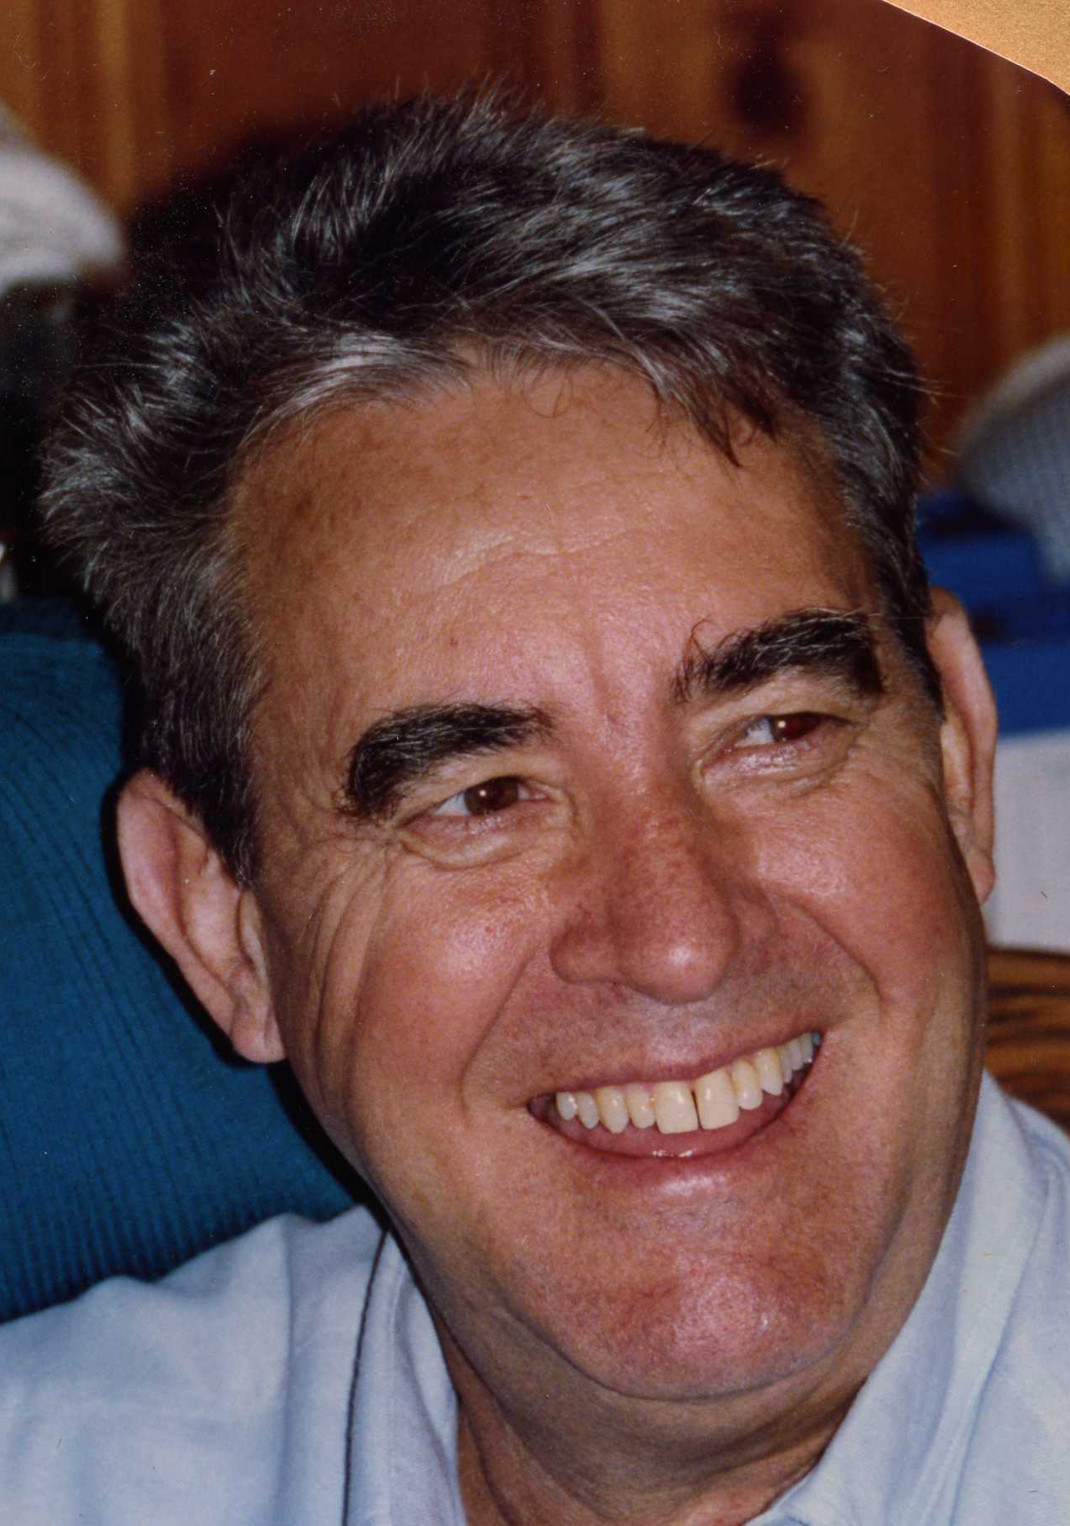

Dr. Don Osbourne Gay, age 80, died Monday, 19, 2014, at his residence.

Dr. Gay was born in Portal, Georgia to the late Doy Osbourne Gay and Thelma Johnson Gay on September 24, 1933. He moved to Monticello in 1940. He served as a fighter pilot from 1953 until 1962 in the United States Air Force. He graduated from the University of Georgia School of Veterinary Medicine in 1968. He devoted the next forty years to his veterinary practice in Monticello.

He is survived by his wife, Ann Blackwell Ballard Gay of Monticello; son and daughter-in-law, Doy and Stacey Gay of Winder; daughters and sons-in-law, DeAnn and David Morrison of Monticello, Betsy and Mark Spevacek of Lilburn, Kay and Phillip Greene of LaGrange, Clair and Billy Coley of Eatonton, and Alyce and Jon Vining of Greensboro; grandchildren, Lauren Morrison, Buddy Morrison, Sarah Gay, Connor Gay, Travis Greene, Ashley Greene, Garrison Coley, Anna Clair Coley, Brigham Vining, Aly Griffin and Laney Spevacek; and sister, Gwendolyn Wade of Covington.

Funeral services will be held at 11:00 A.M., Wednesday, May 21, 2014, at the Monticello Baptist Church. Interment will be held in West View Cemetery. Dr. Robert Whitmire will officiate.

Serving as pallbearers will be his grandchildren.

The family will receive friends from 10:00 A.M. until 11:00, Wednesday, May 21, 2014, at the Monticello Baptist Church Fellowship Hall, prior to the service.

The family suggests in lieu of flowers remembrances can be made to the Monticello Baptist Church, 334 W. Greene Street, Monticello, Georgia 31064; or the Jasper County Humane Society, 2526 Alexander Road, Monticello, Georgia 31064; or the Jasper County Animal Control, 126 Mack Tillman Drive, Monticello, Georgia 31064.

Jordan Funeral Home is in charge of arrangements.

Jordan Funeral Home, Inc.
PO Box 46
Monticello, Georgia 31064
706-468-6303
Fax: 706-468-2205
Email: jordanfh@bellsouth.net

