Mrs. Vera Gotel Greene
August 27, 1953 - January 22, 2022

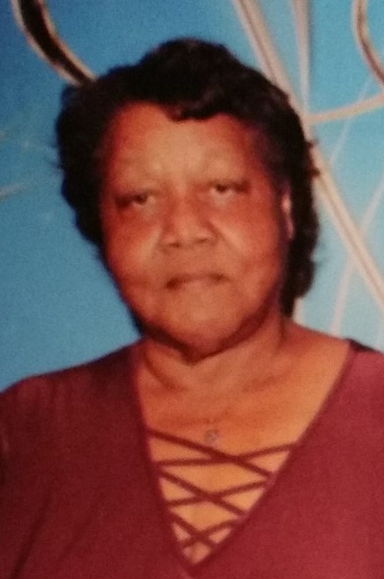
Mrs. Vera Gotel Greene was born in Monticello, Georgia to Ralph and Dorothy Mae Gotel on August 27, 1953. Vera was educated in the Jasper County Public school system. She proclaimed Christ at an early age and joined St. John C.M.E. Church and later moved her membership to Greenwood Baptist Church where she served faithfully on the Kitchen Committee and as Treasurer of the Sunday School.
Vera was joined in Holy Matrimony to Willie F. Greene on June 21, 1970, and to this union four children were born. She also raised her great-niece. Over the years, she was employed by Monticello Manufacturing, Family Connection, and the Monticello Motel. Vera loved children and was instrumental in assisting to raise many of her nieces and nephews. On any given day, you would find the house full of children and in her direct, yet witty way she would impart wisdom on all in her presence. She also enjoyed baking and was famous for her red velvet cakes. She would feed anyone that was hungry and lend a helping hand to others in need. Vera departed this life unexpectedly on January 22, 2022, at Emory Hospital, and left a void that only God can fill.
Vera is preceded in death by her parents Ralph and Dorothy Gotel; stepmother, Mildred Carter Gotel; sister, Gloria J. Gotel; and brother Raymond Gotel. She leaves to cherish her memory: husband, Willie F. Greene, Monticello, GA; children, Lawanda R. Greene , Macon, GA; Roberta D. “Cookie” Greene, Monticello, GA; Courtney L. Greene, Macon, GA; Brian C. Greene, Monticello, GA; and Leneka K. “Nunu” Gotel , Monticello, GA. Grandchildren: Kyla L. King, Kaisley D. Carter, and Kaniya J. Mullins. Special nieces and nephews: LaTonya M.(Tracey) & Tristian Little; Raymond C.(LaToya) & Kaden Gotel, Damien, Natalia S., Benaiah, and Diontae Gotel. Siblings: Walker (Jennifer) Gotel, Covington,GA; Nellie Mae (Charlie Rufus) Eubanks, Covington, GA; Ralph (Alicia) Gotel, Social Circle, GA; Jeanette (Ryan) Abner, Covington, GA; and Michael (Marlyce) Gotel, Monticello, GA. Mother-in-law, Roberta “Honey” Greene, Shady Dale, GA; Godson, Gretarius Stewart; Goddaughter, Aneah Moore; and a host of nieces, nephews, aunts, uncles, cousins, and friends. Vera will be tremendously missed for her mark on our lives was impeccable. Sleep on dear mother and take your rest. We loved you dearly, but God loved you best.
Funeral services will be held at 12:00 Noon, Saturday, January 29, 2022, at Greenwood Baptist Church in Shady Dale. Interment will be held in Shady Dale Community Cemetery.
The family will receive friends, Friday, January 28, 2022, from 4:00 P.M. until 6:00 P.M. at Jordan Funeral Home; and Saturday, January 29, 2022, from 10:00 A.M. until 12:00 Noon, at Greenwood Baptist Church in Shady Dale.
Jordan Funeral Home is in charge of arrangements
.

