Tim Andrew Haase

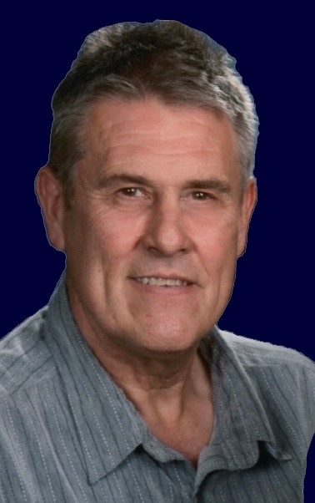
Tim Andrew Haase age 67, peacefully passed away Sunday, January 30, after a very short, but hard-fought battle with cancer.

Tim was born to the late Richard Lee Haase of Cle Elum, WA and Louise Petrich Haase of Cle Elum, WA on November 7, 1954 in Ellensburg, WA. Tim spent his early years in Cle Elum, where his grandparents Augie and Mary Petrich, and Maynard and Mary Haase also lived. After divorcing, Louise married Robert Oscar Iverson of Centralia, WA, and they moved to Poulsbo, WA, then later settling in Bellevue, WA where they both were teachers. Three more sons were added to the family and it was a happy home full of boys. Tim was the ultimate big brother. He spent weekends in the summer with his father on the other side of the Cascade mountains hunting, fishing and enjoying rural life.

Tim was a great athlete from an early age, and a standout Little League pitcher and Boys Club Basketball player. In 1968 his family went to live in Lutterworth, England for a year via the Fulbright Scholarship teacher exchange program. It was a challenge at first for Tim, but he quickly blended right in on the soccer pitch and took in the blossoming English music scene. In the summer all six would travel across Europe in a Volkswagen van to the former Yugoslavia (now Croatia), to see relatives. When Tim returned to WA, he began to focus on basketball and would achieve a First Team All-District award. He graduated in 1973 from Bellevue High School and then went on to Central Washington University on a full basketball scholarship. Sadly, a year later, a knee injury would end his college basketball career.

Tim lived in Cle Elum, WA for years where he worked as a logger, a job he dearly loved. More injuries forced him to choose another path, and he became an over the road truck driver. He met his future wife Tamara Cobb during this time and followed her to her birthplace in GA, where they married, started a family and made Mansfield their home. He drove for Peachtree Doors and Windows, Pratt Industries and retired from Collins Trucking in Jackson, GA

Tim was a big man with a big heart, who loved and sacrificed so much for his family. He really loved music and got to see many Rock, Blues and Jazz greats perform live. He loved logging, hunting elk, mule deer and fishing for steal head trout in the rivers of WA.

He leaves behind a wife of twenty-two years, Tamara Cobb Haase; daughter Katherine Anne Haase; and a son Ben August Haase. Tim was preceded in death by his father Richard Haase, and stepfather Robert Oscar Iverson. He is survived by brothers Rob Iverson (Cheryl) of Roslyn, WA; Garth Iverson (Maria) of Mesilla, NM; Vince Iverson (Sienna) of Seattle; Kevin Warren of Ellensburg, WA; father-in-law Wesley Cobb (Linda) of Mansfield, GA; brother-in-law Scott Cobb (Jennifer) of Grayson, GA; seven nieces and one nephew. He also leaves behind many lifelong friends who were like brothers to him.

The service will be held at 3 p.m., Sunday February 6, 2022 at Monticello Baptist Church. Visitation will precede the service from 2 p.m. until 3 p.m. Pastor David Artessa and Pastor Bob Wooten will officiate.

Jordan Funeral Home is in charge of arrangements.

