Jordan Funeral Home, Inc.
PO Box 46
Monticello, Georgia 31064
706-468-6303
Fax: 706-468-2205
Email: jordanfh@bellsouth.net

Robert Herschel Lewis

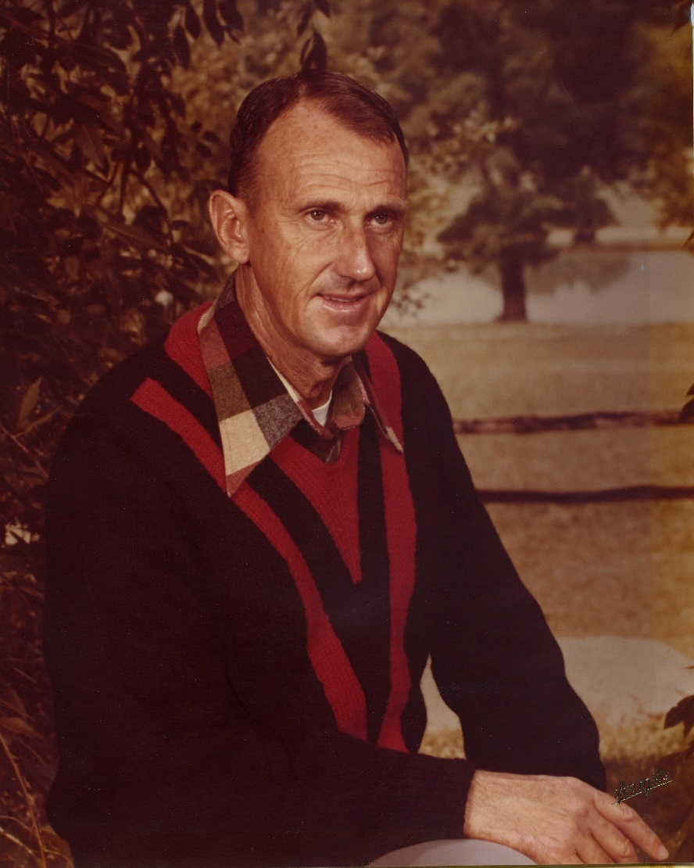
Robert Herschel Lewis, born November 22, 1933, to his parents George and Cornelia Kelly Lewis in Jasper County, died March 27, 2020 at his home in north Jasper County. Robert graduated from Monticello High School in 1950 and after working for several years at the City of Atlanta, he joined the Air Force in 1954.

He was stationed at Lackland Air Force Base in Texas and later was a member of the 30th Bomber Squadron at Homestead Air Force Base in Florida, where he was once chosen as the 19th Bomb Wing Maintenance Man of the Month. His supervisors continuously commended him on his attitude and exemplary manner in which he performed all his duties. The constant comment in referring to him was his outstanding dependability. His award stated, “One can assign A/1C Lewis a task and promptly relieve one’s mind with the assurance that it will be done efficiently and in the least possible time.” Those characteristics remained a constant in his life. His most memorable service experience was participating in the Goodwill Tour of Africa during the Korean Conflict. Robert was honorably discharged with the rank of Staff Sergeant from active duty in 1958.

After returning home from the Air Force, Robert returned to his job at the City of Atlanta and remained there in a supervisory position until he took early retirement in 1992. Robert married Rose Catherine Hughes in 1963 and was the quintessential family man. He was faithful to his Lord and his church, Prospect United Methodist Church, having joined at the age of 12. Although, he was a quiet man by nature, he loved to talk to anyone about the Georgia Bulldogs and NASCAR Racing. He and Rose enjoyed attending the Georgia home games for many years.

In addition to his parents, Robert was preceded in death by his sisters, Emma George Lewis and Carolyn Lewis Goolsby and two babies. In addition to his beloved wife Rose, he is also survived by his beloved daughter Robin Lewis (Patrick) Carey of Mansfield; very special grandsons Adam Kyle (Chelsea) Lewis, Travis Walter Queen, and Hayden Robert Carey, and precious granddaughter Catherine Elizabeth “Katybeth” Carey. He is also survived by his sweet great grandchildren, Macy Leigh Lewis and Patterson Herschel Lewis. In addition, he is survived by his brother Julius Benjamin (Janis) Lewis of Monticello; and numerous cousins, nieces and nephews.

A graveside service will be held at 2:00 P.M., Sunday, March 29, 2020, at Prospect United Methodist Church Cemetery in Mansfield. Pastor Charles Starr and Rev. Mike Willard will officiate.

Condolences may be sent to the family using the guest book on this website.

The family suggests in lieu of flowers donations be made to the Leukemia & Lymphoma Society (LLS) at donate.lls.org.

Jordan Funeral Home is in charge of arrangements.

