**Jordan Funeral Home, Inc.**

**PO Box 46**

**Monticello, Georgia 31064**

**706-468-6303**

**Fax: 706-468-2205**

**Email: jordanfh@bellsouth.net**

**Hal Lancaster Lynch, Jr.**

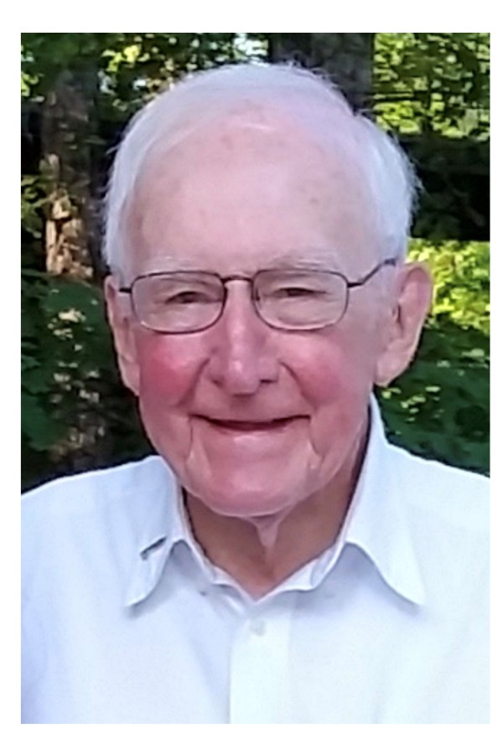Hal Lancaster Lynch Jr., of Jacksonville, Florida, passed away peacefully at his home on Thursday, July 31, 2025. He was 96 years old.

Hal was born in Jacksonville, Florida on July 15, 1929, to parents Hal Lancaster Lynch Sr. and Finney Persons Lynch.

Hal was educated in the Duval County School system and graduated from Lee High School with the class of 1947. Hal attended Duke University, graduating in 1951 with a degree in Business. After graduating from Duke, Hal entered the United States Coast Guard as a commissioned officer serving on the USCGC Buttonwood in Honolulu, Hawaii. While serving in Honolulu, Hal met his future wife Frances Antoinette Leimamo Thompson. The couple were married in 1953 in Honolulu and returned to Jacksonville to begin their life together.

Hal's father, Hal Lynch Sr., owned the North Florida Lincoln Mercury dealership in Jacksonville and Hal grew up learning the car business from an early age. He then took the reins from his father in 1964. Over the coming decades, Hal was able to expand the business to include other dealerships in Jacksonville and Daytona Beach, Savannah, Albany and Thomasville, Georgia, and Auburn, Alabama. His businesses included Gateway Camper Center and Budget Rent-a-Car in Jacksonville. In addition to his car businesses, Hal and his brother Larry Lynch owned a family beef cattle operation in Shady Dale, Georgia for many decades. These businesses continue to operate under current family ownership. In banking, Hal served many years as a Board of Director for Ameris Bank, a NYSE company.

In November, 2024, Hal was inducted into the Florida Automobile Dealers Association Hall of Fame, which recognized his contribution to the automotive industry and to the Jacksonville community.

In his civic life, Hal always strived to model service above all else. He served on several boards including the Bolles School Board of Trustees, where he served as Chairman from 1990 to 1992, remaining as a dedicated Trustee Emeritus for many years that followed. He was a member and past chairman of the Exchange Club of Jacksonville for 60 years, and a supporter of the Exchange Club Family Center dedicated to the prevention of child abuse. He also mentored children in the local PAL's program.

Hal and Frances loved hosting friends in their home, often entertaining large groups with jam sessions and sing-a-longs. Frances would play the piano, guitar and ukulele, with Hal energetically strumming on a washtub gut bucket. While Frances had by far the more melodious voice, Hal always sang along with abundant gusto.

Hal and Frances were also avid Florida Gators football fans. They held season tickets since the early 1950's and would drive their motor home to nearly every home game, bringing friends along to help them tailgate. They were members of the Bull Gator Association and attended NCAA National Championships for both Gator football and basketball.

Hal was a long-time member of Timuquana Country Club, serving as club president in 1986. He helped form a Friday night Timuquana dinner group, which faithfully met nearly every week for more than fifty years. Some of his closest relationships were formed through this group.

Throughout his career and life, Hal valued family, friends, integrity and faith above all else. He always went out of his way to treat others with fairness and kindness. He was a faithful member of Riverside Baptist Church for over 90 years, serving on many committees and taught Sunday School for over 60 years. He was a role model to his family with his daily morning Bible reading, devotion, and prayer time.

He is survived by his four children: Hal Lynch III (Brian), Helen Lynch Cooper (Charles), William Lynch (Jeanie), and Robert Lynch (Ann), six grandchildren: Bryce Cooper, Adra Cooper Lobdell (Tyler), Conrad Lynch (Katie), Lindsay Lynch, Amanda Lynch Ponson (Magnus), Adam Lynch, five great-grandchildren: Lucy Lynch, Josie Lynch, Hal Lobdell, Cooper Lobdell, Emmie Lynch, and numerous nieces and nephews.

The family is deeply indebted and grateful to the caregivers who worked to assure Hal’s comfort and well-being: Diane Reed, Dawn and Aaron Frazier, Cherryl “Black” Mincey, his physical therapist, Geoff Angel, and his primary care physician, Dr. Tea Stephens.

Hal will be laid to rest beside his beloved Frances in Shady Dale, Georgia on Saturday, August 9, 2025. The service will be held at Providence Baptist Church, 520 South Railroad Street, Shady Dale, Georgia. Visitation will begin at 10:30 a.m. immediately followed by the funeral service and graveside. Rev. Ed Westbrook will officiate.

Pallbearers will be: Hal Lynch III, William Lynch, Robert Lynch, Charles Cooper, Brian Wilkinson, Conrad Lynch, Adam Lynch, and Magnus Ponson.

The family suggests in lieu of flowers that donations be made to The Community Foundation for Northeast Florida, 245 Riverside Avenue, Suite 310, Jacksonville, Florida 32202.

Jordan Funeral Home is in charge of arrangements.