**Jordan Funeral Home, Inc.**

**PO Box 46**

**Monticello, Georgia 31064**

**706-468-6303**

**Fax: 706-468-2205**

**Email:** [**jordanfh@bellsouth.net**](mailto:jordanfh@bellsouth.net)

**Nancy Matthews Lynch**

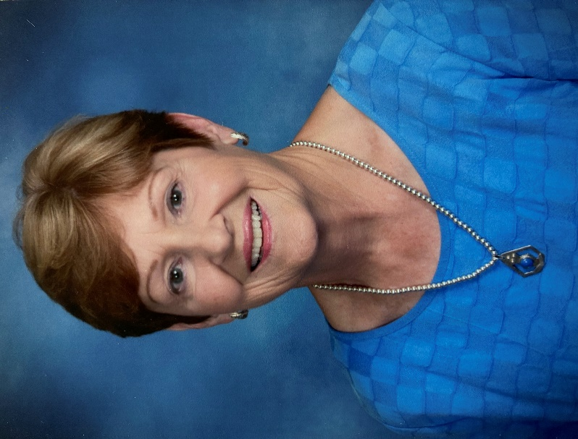Nancy Matthews Lynch, age 81, passed away peacefully in her home on Shadydale Farm on July 24, 2025. Nancy was born in Jacksonville, Florida on June 4, 1944, to the late Henry Belle Matthews and Betty Ward Matthews. Nancy grew up in the Avondale neighborhood, attended neighborhood schools, graduated from Lee High, and obtained a bachelor’s degree in music from Jacksonville University.

Nancy loved her Lord and Savior, her family, her friends, and her church. She showed her love for them by serving consistently and dependably. Because of her service and love, many people’s lives were changed and her legacy will not be forgotten. Nancy used her passion for music to serve; singing solely and collectively in church choirs and directing the MBC junior choir. It was while she was serving in the church choir in her home church of Riverside Baptist where she first caught the eye of Larry Lynch, who soon would become her husband of sixty years until his passing in September of 2024. Larry and Nancy moved from Jacksonville to Monticello in 1969 where they lived and raised their family.

Nancy served her local church, Monticello Baptist, for fifty-six years in many ways. She was a member of the WMU serving as both local director and regional president, the women’s Sunday school teacher, GA leader, and as a member of various committees.

Nancy served her community as being one of the inaugural members of the Care Corps in which she served for many years. She started the Women’s Club and was involved with the American Cancer Society. Nancy, along with her husband Larry, created and promoted the Jasper County Mentor Program through which they made a difference in many young peoples’ lives.

Nancy is survived by her children Tom Lynch (Gretchen) of Jacksonville, Florida, Jim Lynch (Erin) of Shady Dale, Betsy Cain (Buddy) of Monticello; grandchildren Abigail Lynch, Henry Lynch, Emmett Lynch (Kelly), Braden Lynch, Ben Lynch, Ethan Lynch, Chad Cain (Marley), Jeff Cain (Lauren), and Matt Cain; great-grandson James Thomas Lynch; brother Ward Matthews (Deanna) of Nashville, TN; brother-in-law Hal Lynch, Jr. of Jacksonville, Florida; many nieces, nephews, and cousins.

The family will be forever grateful for the care her caretakers provided for Nancy: Tomasia Ammons, Lorraine Clonts, Terri Mooney, Rebekah Stone, Christy Whitley, and Erin Williamson.

Serving as pallbearers will be Chad Cain, Jeff Cain, Matt Cain, Ben Lynch, Braden Lynch, Emmett Lynch, Ethan Lynch, Henry Lynch.

The family will receive friends from 5:00 P.M. until 7:-00 P.M., Friday, August 1, 2025, at the Monticello Baptist Church. Funeral service will be held August 2, 2025 at 11:00 A.M., at the Monticello Baptist Church. Interment will follow at Providence Baptist Church in Shady Dale.

Dr. Bob Whitmire and Dr. Jim Renault will officiate.

The family suggests in lieu of flowers, donations be made to the Jasper County Care Corps, 227 Davis Carter Road, Monticello, Georgia 31064; or Monticello Baptist Church, 334 W. Greene Street, Monticello, Georgia 31064.

Jordan Funeral Home is in charge of arrangements.