Jordan Funeral Home, Inc.
PO Box 46
Monticello, Georgia 31064
706-468-6303
Fax: 706-468-2205
Email: jordanfh@bellsouth.net

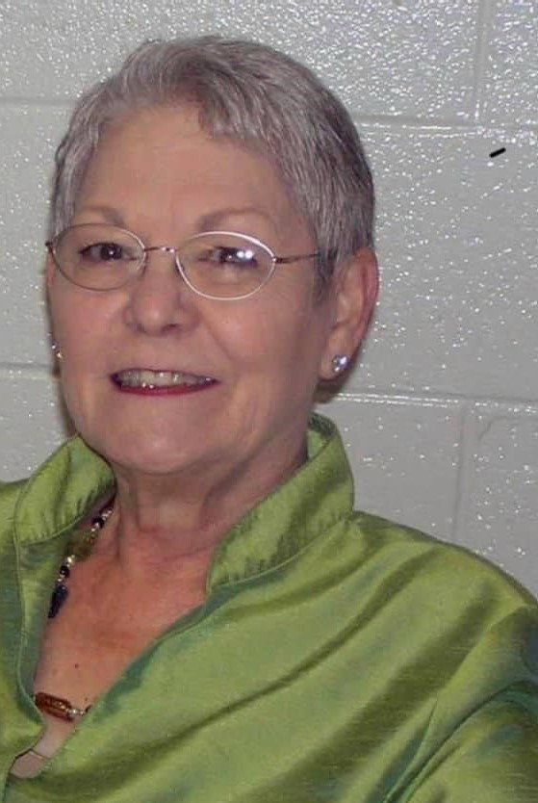
Laura Gayle Tillman Marsh, age 75, of Hillsboro lost her battle with cancer on January 21, 2022, at Pine Pointe Hospice in Macon, Georgia and will be missed by many friends and family members.

Gayle Marsh was born on January 25, 1946, at the home place in Hillsboro to the late John Taylor “J. T.” Tillman and Marie Goolsby Tillman. In addition to her parents, she was preceded in death by her brother, Floyd Tillman; nephew, Ken Tillman; and niece, Meredith Tillman.

Gayle was a 1964 graduate of Monticello High School and attended Crandall Business College in Macon from 1965 until 1966. She married “Ronnie” Marsh on August 5, 1966 and they moved to Griffin, Georgia for two years. She returned to Hillsboro in 1969, where she lived the remainder of her years.

Gayle began working for Bank South and retired from McIntosh State Bank as a Vice President on December 31, 2001.

After retirement, Gayle helped raise grandchildren and took great pride in the Grandparent’s Club at Piedmont Academy which she started. She also prepared lunch every Sunday for her family whom she loved dearly. She was lovingly known as “Gayle”, “Mother”, “Mama” and most importantly, “Gammy”.

Gayle was a member of Hillsboro Baptist Church. She enjoyed working for and with others and overcame many health related obstacles to continue helping others.

She is survived by her loving husband of fifty-six years, William Ronald Marsh of Hillsboro; children, Brian (Tanya) Marsh of Hillsboro, Lee Marsh of Milledgeville and Lori Wilkes of Hillsboro; grandchildren, Remington Marsh, Mitch Marsh, Elizabeth Marsh and Greta Wilkes; brother, Ronnie (Kathy) Tillman of Hillsboro; sister-in-law, Diane Marsh of Florida; brother-in-law, Terry Marsh of Juliette; and many nieces and nephews.

A memorial service will be held at 2:00 P.M., Monday, January 24, 2022, at the Monticello Baptist Church. Rev. Greg Marsh will officiate.

The family will receive friends from 1:00 until 2:00 P.M., Monday, January 24, 2022, at the Monticello Baptist Church Fellowship Hall.

The family suggests in lieu of flowers, donations be made to the Piedmont Academy Grandparent’s Club, 126 GA-212 W, Monticello, Georgia 31064.

Jordan Funeral Home is in charge of arrangements.

