Belle Miller McMaster

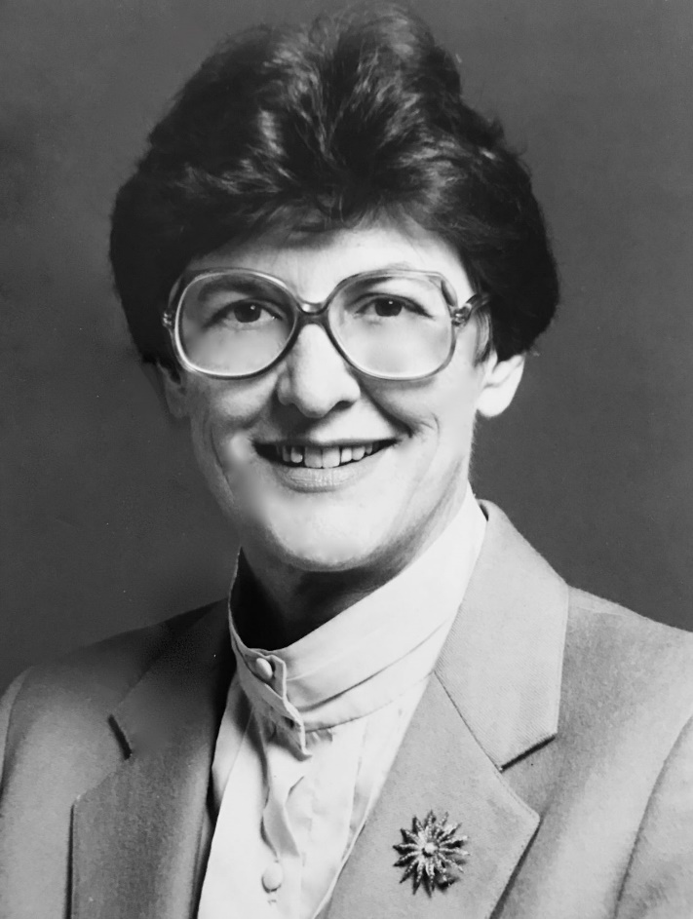
Dr. Belle Neel Miller McMaster died peacefully on January 26, 2023, at the Retreat Nursing Home in Monticello, GA. She was born May 24, 1932, in Atlanta, GA to Dr. Patrick Dwight Miller and Lila Bonner Miller, MD and was eldest sister to the Rev. Dr. Patrick Miller, Jr, who preceded her in death in 2020, and the Rev. Dr. Mary Miller Brueggemann currently living in Black Mountain, NC.
Belle graduated from Thomas Jefferson High School in San Antonio, TX in 1949 and magna cum laude from Agnes Scott College in Decatur, GA in 1953 with high honor. She was married to the Rev. George Riley McMaster, a pastor in the Presbyterian Church (USA) for 52 years until his death in 2005. Together they served communities all over the Southeast. Their three children include: Marie Elizabeth McMaster Stork (John) of Monticello, GA, George Neel McMaster of Avondale Estates, GA and Patrick Miller McMaster (Alice) of Athens, GA, and four grandchildren, Margaret Bonner Stork van Swelm (Brett), Belle Miller Stork Perry (Ben), Lila Frances McMaster, and George Ellis McMaster and four great-grandchildren, Marie Elizabeth Perry, Reid Hirst van Swelm, Davis Cantzon Perry, and Olive Louise van Swelm.
Belle was a life-long learner and an avid reader and writer. In her 40s, she returned to school at the University of Louisville where she received an MA in 1970 and a PhD with honors in 1974. When Belle began work, she was driven by her faith and her deep commitment to social justice for all. She worked for the Presbyterian Church (USA) from 1974 until 1993 serving in Social Justice and Peacemaking in both Atlanta and Louisville, KY. She represented the Presbyterian Church at the National Council of Churches, Church World Service, World Council of Churches, and World Alliance of Reformed Churches, holding key leadership roles in all four organizations. Her work often took her around the world to learn and serve in an official ecumenical capacity with other Christians, including representing the Presbyterian Church at the Beijing Conference on Women in 1995. From 1993-2003, she taught at Candler School of Theology, Emory University, Atlanta, serving as Director of Women in Theology and Ministry and of Advanced Studies. After her retirement she continued her faithful service working at Druid Hills Presbyterian Church in Atlanta, GA, where she was a member, Elder, Clerk of Session, coordinator of the Men’s Night Shelter, and later Elder Emeritus. In 2015, she moved to Monticello, GA where she lived with Lisa and John Stork and was an active member of Monticello Presbyterian Church. Belle leaves a legacy of social justice work that will continue to impact many lives for years to come.
A memorial service will be held at Monticello Presbyterian Church on Saturday, February 25, 2023, at 1:00 PM. Gifts may be given to Monticello Presbyterian Church, P.O. Box 308, Monticello, GA 31064.

