Jordan Funeral Home, Inc.
PO Box 46
Monticello, Georgia 31064
706-468-6303
Fax: 706-468-2205
Email: jordanfh@bellsouth.net

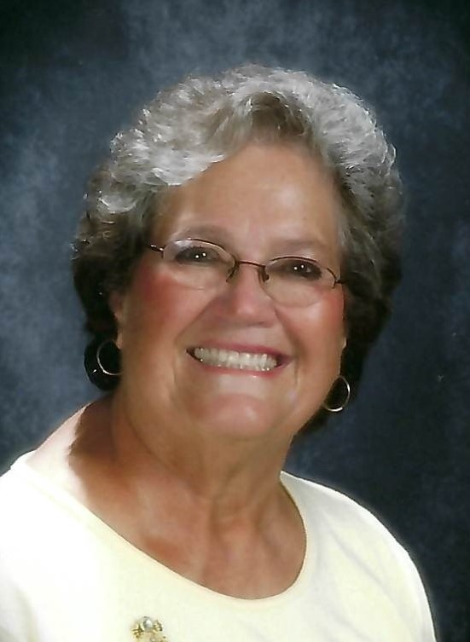

Betsy Louise Turner Moore, age 81, passed away Sunday, January 17, 2021, at The Retreat Nursing Home.

Betsy Moore was born in Lancaster, South Carolina to the late Robert Harold Turner and Mattie Louise Turner of Taylors, South Carolina. Betsy grew up in Taylors and graduated from Taylors High School. There she met her high school sweetheart and future husband, John Wesley Moore. They were married fifty-five years until his death in 2011.

Betsy was a devoted wife, mother, grandmother and great grandmother. She taught and touched the lives of numerous children before and after moving to Monticello, Georgia. She taught pre-school at the First Baptist Church, the First United Methodist Church and at Piedmont Academy in Monticello for seventeen years. She was known as “Miss” Betsy and was dearly loved by all the children. Betsy was a member of the First United Methodist Church and deeply loved her church family.

She also loved cooking, cheering on the Clemson Tigers, and loving and taking care of the many pets she had throughout the years. More than anything, she loved spending time with her two daughters, grandchildren, great grandchildren and family. Family was everything to Miss Betsy.

Miss Betsy always had a beautiful smile and lots of warm hugs for everyone. Her cheerful personality made everyone always feel comforted, loved and welcome.

In addition to her parents, she was preceded in death by her loving husband, John Wesley Moore; and sister and brother-in-law, Bobbie Jean Bulloch and Jimmy Bulloch.

She is survived by her daughters, Cynthia (James L.) Adams of Wilmington, North Carolina and Julie Aileen (Thomas R.) Tucker of Monticello, Georgia; grandchildren, Brandon John (Annie) Adams and Ashley Louise Adams of Wilmington, North Carolina and Carrie Aileen (Brandon) Phillips of Tifton, Georgia; great grandchildren, Levi John Adams, Olivia Anne Adams and Betsy Grace Phillips; brothers, Don (Lois) Turner of Greenville, South Carolina and Hal (Carolette) Turner of Columbia, South Carolina; and a number of nieces and nephews.

A graveside service will be held at 2:00 P.M., Thursday, January 21, 2021, at Lawrence Chapel United Methodist Church Cemetery in Central, South Carolina. Dr. John Brown will officiate.

The family suggests in lieu of flowers donations be made to the Monticello First United Methodist Church 651 College Street, Monticello, Georgia 31064; or Piedmont Academy 126 Hwy 212 W Monticello, Georgia 31064.

Jordan Funeral Home is in charge of arrangements.

