**Jordan Funeral Home, Inc.**

**PO Box 46**

**Monticello, Georgia 31064**

**706-468-6303**

**Fax: 706-468-2205**

**Email: jordanfh@bellsouth.net**

**In Loving Memory of Roy Vincent Price, Jr.**  
*February 18, 1941 – Month, Date 2025*

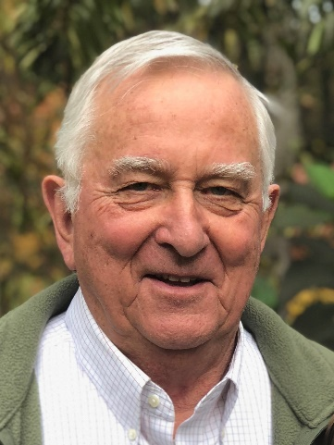We announce with deep sorrow the passing of our beloved Roy Vincent Price, Jr., age 84, of Atlanta, Georgia, who departed this life peacefully on June 28, 2025.

Roy was born on February 18, 1941, in Atlanta to the late Martha Hardy Price and Roy Vincent Price, Sr. He spent his formative years in Monticello, Georgia, and later earned a Bachelor of Science degree from the University of Georgia, where he began a lifelong devotion to the Georgia Bulldogs.

Roy built a long and rewarding career in banking and sales, forming many cherished and lasting friendships along the way. He will be remembered not only for his professional integrity but also for his warmth, sense of humor, and ability to connect with everyone he met.

A passionate sportsman and gifted athlete, Roy found great joy in golf, tournament sporting clays, and cheering on his Bulldogs every season.

He is survived by his loving sons, Wellborn Vincent Price (Michael Ann) of Atlanta and Byron Davis Price (Shannon) of Atlanta; and by his treasured grandchildren: Regan Elizabeth Price, Ryan Olivia Price, Wellborn Vincent Price, Jr., Cole Thomas Price, Janie Fleming Price, and Edward Hardy Price, all of Atlanta. He is also survived by his devoted sisters, Elizabeth Price Walden and Louise Price Bruner; his niece Jill Martha Bruner Harden (Ron); nephew Daniel Jared Walden; great-niece Martha Elizabeth Harden; great-nephew George Avery Harden; and numerous extended family members and friends who will miss him dearly.

Roy’s legacy of kindness, laughter, and loyalty to family and friends lives on in all who knew and loved him.

The family will receive friends from 10:00 A.M. until 11:00 A.M., Thursday, July 3, 2025, at Jordan Funeral Home.

Funeral services will be held at 11:00 A.M., Thursday, July 3, 2025, at the Chapel of Jordan Funeral Home. A private family interment will follow at West View Cemetery. Rev. David Artessa will officiate.

Serving as pallbearers will be Chip Benton, Wayne Hansen, Tommy Jordan Walter Tillman, Don McClintock, and Drew McClintock,

Jordan Funeral Home is in charge of arrangements.