Charles Arthur Renz, III

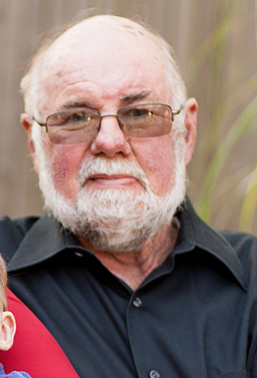
Charles Arthur Renz, III, age 69, of Monticello, formerly of Tampa, Florida, passed away from this life in the company of his wife and children on Wednesday, May 21, 2014, at his home.

Charlie was born in Tampa, Florida to the late Charles Arthur Renz, Jr. and Elsie Mae Sharpe Renz. He served his country in the U. S. Air Force in Vietnam and was the most personable postal clerk for the USPS for over thirty years. People would often jump out of another line just to be served by him. He had a wonderful way of making everyone feel important.

A sports fanatic in every way, he coached his children’s sports teams every chance he got, cheered the loudest for the Florida Gators; and could recite any sports statistic at the drop of a hat.

His quick wit and unquenchable sense of humor made everyone always feel comfortable around him instantly. Charlie and Karen moved to Monticello from Tampa, Florida, just one year ago and in that short time, he made an indelible mark on Monticello. His love for Karen’s cooking, sweet tea, good wine, and leg of lamb were his hallmarks. He loved his family fiercely and we will always love and cherish our time with him.

He is survived by his adoring wife, Karen Chadwick Renz of Monticello; they were married for seventeen years and still madly in love. Charlie was the loving father to Kevin Renz and his wife, Leigh-Ann Renz of Waynesville, North Carolina; Kelly McNeal and her husband, Jim McNeal of Gainesville, Florida; and Christina Bramlett and her husband, Bob Bramlett of Monticello. He was the most proud Grandpa to Teague McNeal, Tevyn McNeal, Anika Renz, and Aiden Bramlett. And he was always loyal to his brother, Ronnie Gilbert and his wife, Reta Gilbert of Kokomo, Indiana.

The family will receive friends at Jordan Funeral Home from 3:00 until 3:30 P.M., Saturday, May 24, 2014, prior to the memorial service in the chapel at 3:30. The family will officiate.

The family welcomes everyone to 2628 Hwy 212 E., Monticello, Georgia 31064, after the service for a reception.

In lieu of flowers, the family requests that either a tree be planted in his honor or donations made to the United Hospice of Macon, 6060 Lakeside Commons, Macon, Georgia 31021; or the American Cancer Society, Hamilton State Bank, c/o Carissa Wilmot, P. O. Box 31, Monticello, Georgia 31064. Jordan Funeral Home is in charge of arrangements.

