Sarah Goolsby Sammons
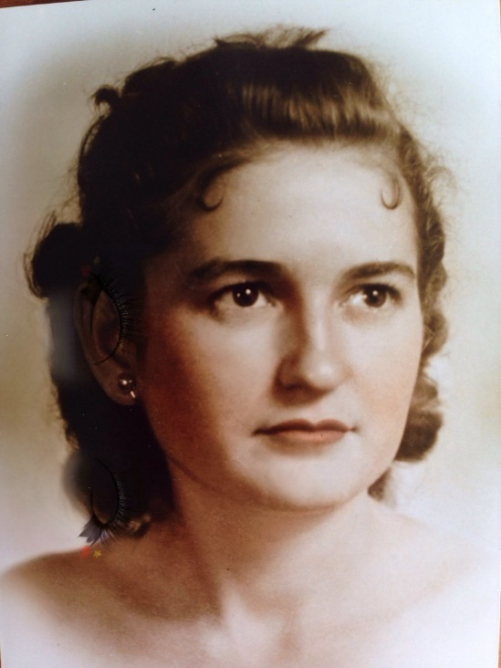
It is with great sadness that the family of Sarah Josephine Goolsby Sammons announces her passing after a brief hospital stay, on Sunday, March 24, 2019, at the age of 90 years.

Sarah is survived by her youngest brother Bennie. Sarah will also be lovingly remembered by her children Ulmont “Bran” Sammons, Sarah “Sally” Sammons, Nancy Sharp (Steve), and John G. Sammons, and fondly remembered by her 8 grandchildren, Kathryn Hattenbach (Preston), Robert Hillis, Steven Sharp (Adum), Chris Sharp, Katy Sharp (Brian), and 7 great grandchildren, Larisa, Nicholai, Justin, Kalub, Keeley, Kacey and Wesley. Including numerous nieces, nephews and extended family.

Sarah was predeceased by her parents, Thomas H. and Susan C. Freeman Goolsby of Hillsboro, GA.
Sarah was also predeceased by her husband, Ulmont B. “UB” Sammons. Brothers and sisters, Laura Childs (Joe), Carlton, Edna Fullerton (Barron), Marie Tillman (J.T.), William (Peggy), Huey, George, Carden (Harristine), and Bennie’s wife Madeline.

Sarah was born on August 13, 1928 in Hillsboro, GA. She was married to UB Sammons on March 15, 1956 in Eatonton, GA. Sarah worked beside her husband at their family owned business, Killeen Hardware, for many years. She enjoyed reading and education. She had a wonderful smile that could light up a room. Sarah was a Christian, selfless and kind. She was devoted to her family and raising her 4 children. She traveled to Cuba before the Cuban Missile Crisis. Sarah enjoyed many trips back to Georgia through the years for family visits.

Graveside services are planned for Saturday, April 20, 2019, at 11.00 A.M., at Pine Grove Cemetery in Eatonton, GA.

Funeral services are provided by Jordan Funeral Home in Monticello, GA.

Good night sweet Momma… and flights of angels sing thee to thy rest. (Shakespeare)

A special thank you to the care teams at Sagebrook Rehabilitation Center in Cedar Park, TX, Compassus Hospice and St. David’s Trauma Hospital in Round Rock, TX for their compassionate care.

