Jordan Funeral Home, Inc.
PO Box 46
Monticello, Georgia 31064
706-468-6303
Fax: 706-468-2205
Email: jordanfh@bellsouth.net

Janet Ruth Sharp
July 19, 1940-January 12, 2024
Janet Ruth Sharp (nee Fyock), 83, of Monticello, Georgia, went home to be with the Lord on Friday, January 12, 2024.
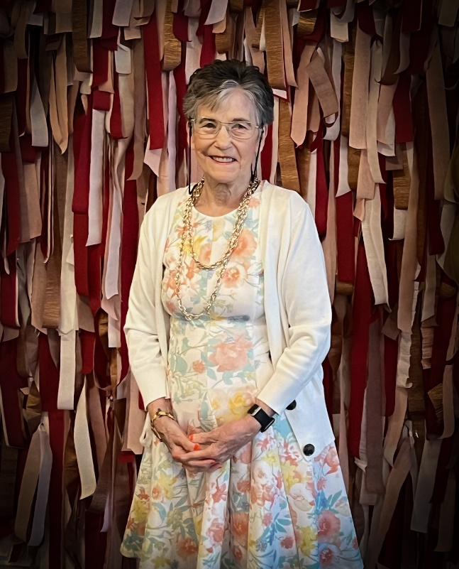
Born in Johnstown, PA on July 19, 1940, Janet was one of fourteen children, and a twin, born to the late Merle E. and Elizabeth Fyock (Held). A self-described tomboy, as a child, Janet loved playing outdoors with neighborhood friends, and spending time with family. She graduated from Conemaugh High School and was so proud of her 11-year perfect attendance record. As a young woman, Janet worked at Penn Traffic, where she was set up on a blind date with the eventual love of her life, George.
Janet married George P. Sharp on October 17, 1964, at St. John Gualbert Cathedral, in Johnstown, PA. They celebrated 59 years of wedded bliss this past October. Janet and George welcomed two loving children: a son, Christopher, and a daughter, Karen.
Janet loved to work, holding positions at the Sheraton Inn, Olde English Inn, and Walmart. Janet made her Hollywood debut, with a cameo appearance in Cannonball Run, which was filmed at the Olde English Inn. She loved gardening and looked forward to planting her favorite colorful flowers. She was also a bingo and trivia champion, and especially loved crossword and word search puzzles. She stayed active by enjoying aerobics classes, even performing at an Atlanta Falcons game. She developed a love of running in her early fifties and won many races in her age group. Janet even won the Energizer Bunny Award, for completing all fifteen track club races. Although her health was declining, Janet completed a 1-mile Fun Run in September of 2023. She felt so blessed to experience her first prom and last dance with her greatest love, George, on September 16, 2023.
Janet was the happiest spending time with her family and friends. She never met a stranger. She looked forward to seeing her family at the annual Fyock and Sharp reunions in July. She was so proud of her grandchildren and relished being a grandmother, attending as many sports and school activities as possible. A woman of profound faith, Janet attended Sts. Peter and Paul Catholic Church, in Decatur, GA.
Janet is survived by her loving husband of 59 years, George; two children: her son, Christopher Sharp (Mishara) of Lake Spivey Estates, GA and her daughter, Karen Lago (Michael) of Acworth, GA; three grandsons: Kyle, Jaden, and Christian; two granddaughters: Brandy (Robert), and Reagan; one great-grandson, Jameson.
Janet is also survived by her siblings Dwight Fyock (Mary), Robert Fyock (Christine), her twin sister Janice Fyock, and Regina Harris, along with a host of nieces and nephews. She was preceded in death by her parents Merle and Elizabeth Fyock, her brothers Bruce Fyock, Arnold Fyock, Kenneth Fyock, and Howard Fyock, her sisters Helen Sustersich, Mary Jane Kleitches, Donna Hillegas, Audrey Fyock, and Arlene Fyock.
A memorial service will be held at a future date, in both Georgia and Pennsylvania.
Janet was a beautiful and gentle spirit and is now our angel.
Jordan Funeral Home was in charge of arrangements.

