Jordan Funeral Home, Inc.
PO Box 46
Monticello, Georgia 31064
706-468-6303
Fax: 706-468-2205
Email: jordanfh@bellsouth.net

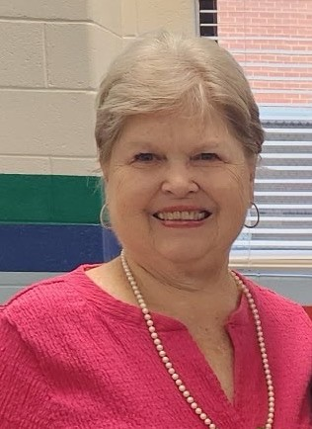
Frances Joan Wells Thornton, age 72, passed away April 20, 2026 with family surrounding her.

Joan Thornton was born January 21, 1954 in Macon, Georgia. Her parents were the late Robert and Margaret Wells. Joan was a 1972 graduate of Jones County High School in Gray. She was a 1976 graduate of Georgia College in Milledgeville.

In addition to her parents, she was preceded in death by her son, Luke Hillyer and a brother, Keith Wells.

She leaves behind her loving husband of fifty years, Sam; and children Andy (Melanie) Thornton of Winder, Georgia and Leigh (James) Cunningham of Newnan, Georgia. She also cherished her grandchildren Ashlyn Thornton, Colton Thornton, Jackson Cunningham, and Bradley Cunningham who lovingly called her Nana. Joan is also survived by her siblings, Tanya (Jimmy) Crum of Bainbridge, Georgia, Bobby (Patty) Wells of Gray, Georgia and twin sister, Jan Young of Macon. Joan and Sam both came from large families so there are numerous nieces, nephews, aunts, uncles, and cousins who will miss her dearly.

Joan was a member of Monticello Baptist Church where she was involved in many committees and activities throughout the years. She had a servant's heart and always was thinking of others and doing anything she can for friends and family. She was a teacher with Jasper County High School where she taught Home Economics for fifteen years. She taught many students how to sew and cook. She even taught evening adult sewing classes. After retiring from teaching, she became the School Nutrition Director for Jasper County School System for sixteen years. She continued to consult with surrounding counties for several years following her retirement with school nutrition.

Joan enjoyed traveling especially to Mexico Beach where she visited all her life. She was always present at any of the grandchildren's sporting events or awards programs. She was their biggest cheerleader! She was always on the go serving others and planning the next event with her to do lists.

Serving as pallbearers will be David Young, Matt Godwin, Aaron Arnett, Will Thornton, Logan Thornton, Jordan Thornton, and Sammy Puckett.

The family will receive friends from 6:00 P.M. until 8:00 P.M., Wednesday, April 22, 2026 at Jordan Funeral Home.

Funeral services will be held at Monticello Baptist Church on Thursday, April 23, 2026 at 11:00 A.M. Interment will be held at 2:30 P.M., Thursday, April 23, 2026, at Elam Baptist Church Cemetery, 203 Elam Church Road, Gray, Georgia 31032.

In lieu of flowers the family suggests donations made in Joan’s memory to Monticello Baptist Church, 334 West Greene Street, Monticello, GA 31064.

Jordan Funeral Home is in charge of arrangements. Please visit our website at www.jordanfuneralhomemonticello.

