Jordan Funeral Home, Inc.
PO Box 46
Monticello, Georgia 31064
706-468-6303
Fax: 706-468-2205
Email: jordanfh@bellsouth.net

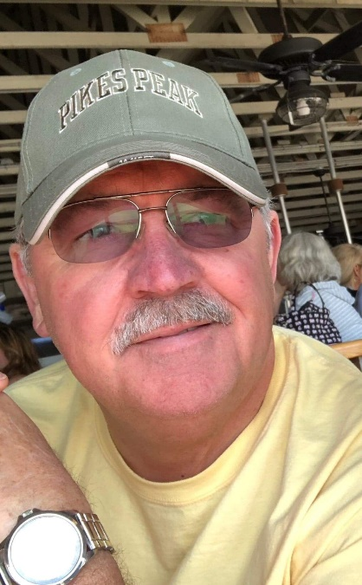

Joseph Daniel “Danny” Wild, age 70, passed away Thursday, April 25, 2019, at his residence. Danny Wild, a lifelong resident of Monticello, was the son of the late Robert Woodrow Wild and Mildred Roper Wild. He served in the U. S. Air Force in Japan during the Vietnam conflict.

Before retirement in 2015, Danny worked in shipping for General Mills. He worked for Georgia Pacific and Larry’s 4-Way for a number of years. While working at Larry’s 4-Way, Danny was famous for his homemade biscuits.

Danny was a member of New Rocky Creek Baptist Church. He loved to travel, spend time with his family, especially his brothers and high school classmates, work in the yard, fly his drone and sing. He was witty and loved to play a good joke on people.

In addition to his father, he was preceded in death by his son, Joshua Daniel Wild.

He is survived by his wife, Helen Owensby Wild of Monticello; daughter, Courtney Marie Wild of Monticello; mother, Mildred Roper Wild of Monticello; sisters and brothers, Linda (Billy) Piper of Mansfield, Martha (Rusty) Duke of Nashville, Tennessee, Larry (Joy) Wild of Monticello and Tony (Janell) Wild of Monticello; a number of nieces and nephews; and grand dog, Osirus.

Funeral services will be held at 3:00 P.M., Saturday, April 27, 2019, at New Rocky Creek Baptist Church in Mansfield. Interment will be held in West View Cemetery. Dr. Randal Reese and Rev. Charles Roper will officiate.

The family will receive friends from 1:00 until 3:00 P.M., Saturday, April 27, 2019, at New Rocky Creek Baptist Church.

Serving as honorary pallbearers will be Wayne Allen, Larry Dean, Wayne Dooley, Tracy Duke, Ronnie Hanson, Dane Jones, Glen McMichael, Royce Roper, Mike Thomason and Garrett Wild.

Jordan Funeral Home is in charge of arrangements. Please visit our website at www.jordanfuneralhomemonticello.com.

